**TYPE CASTING**

1. char to char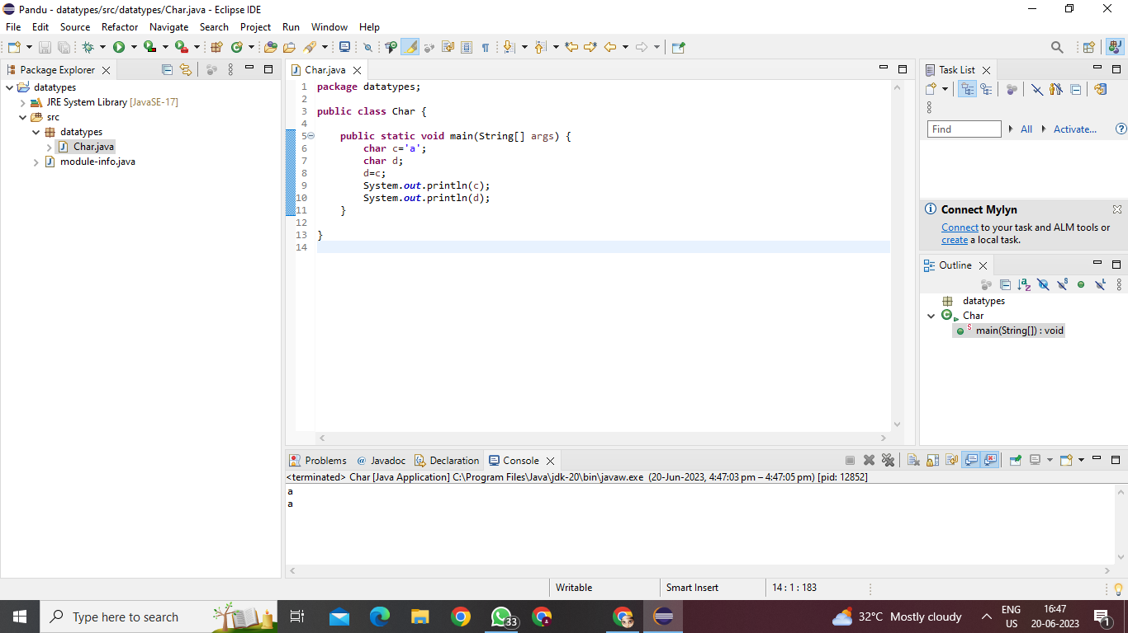

Casting not required

2. char to byte

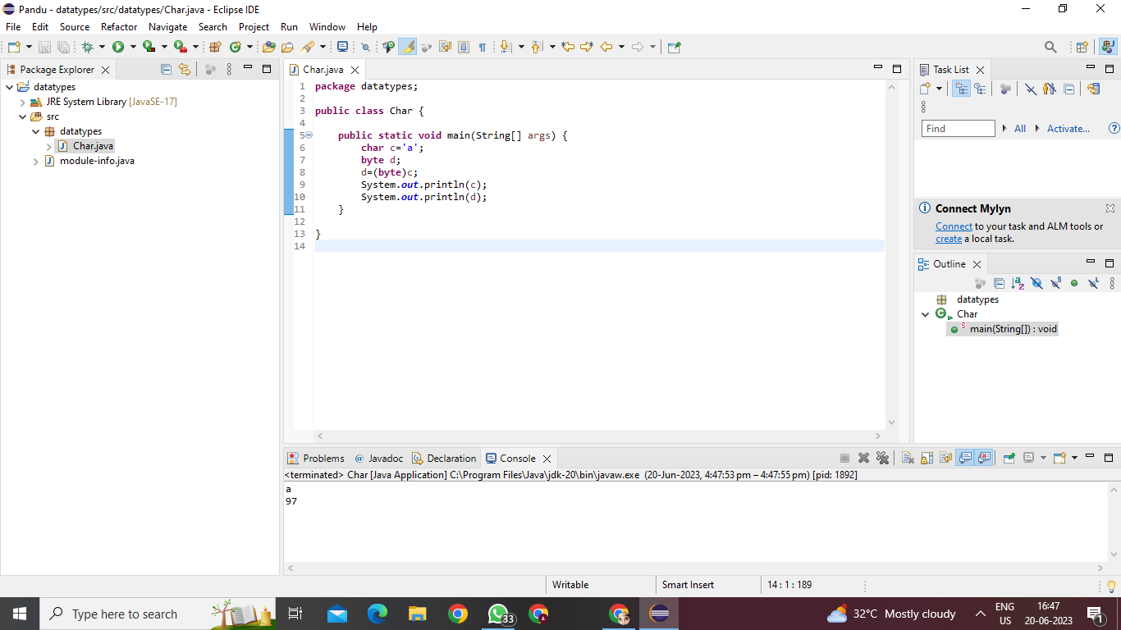Explicit type casting

3.char to short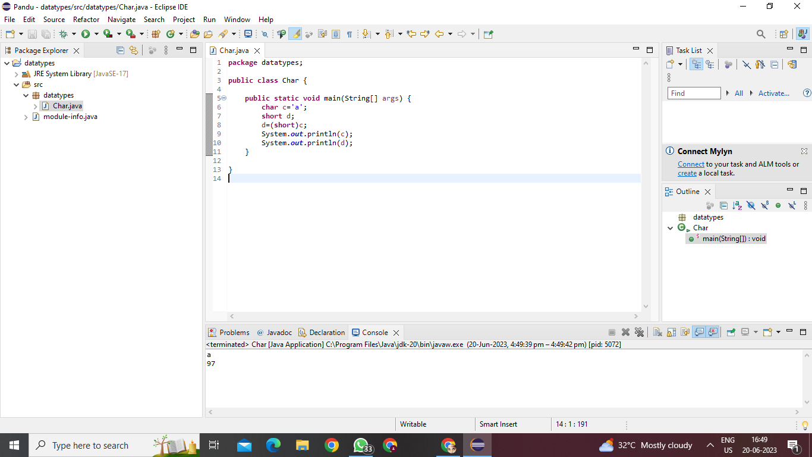

Explicit type casting

4. char to int

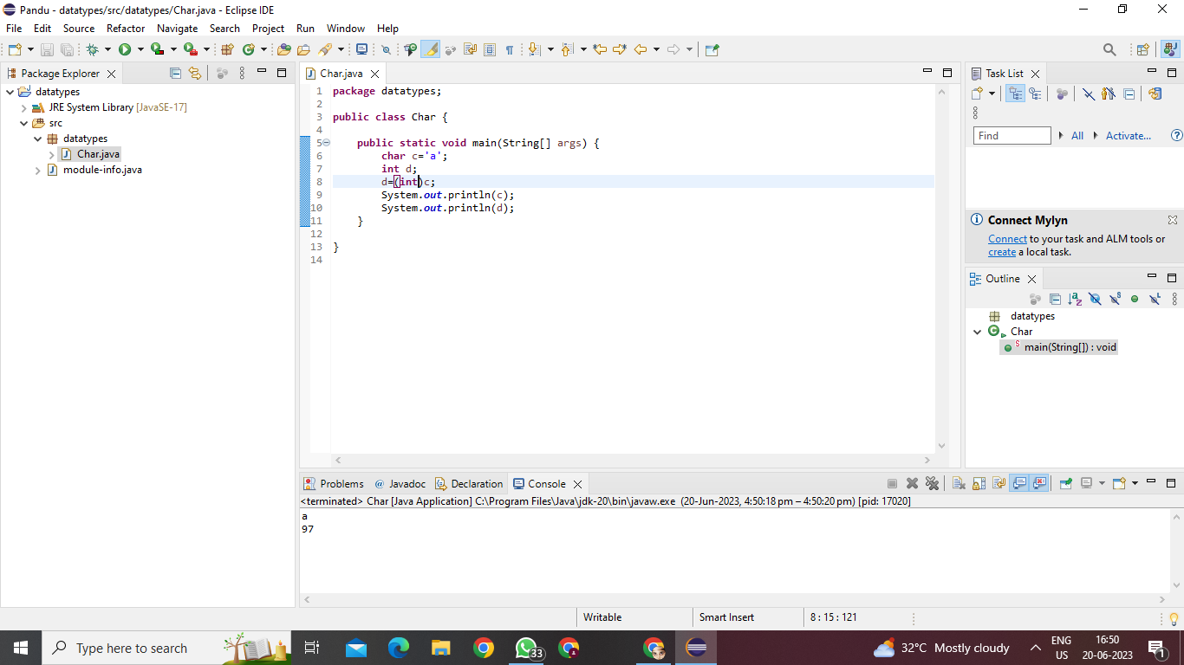

Explicit type casting5. Char to long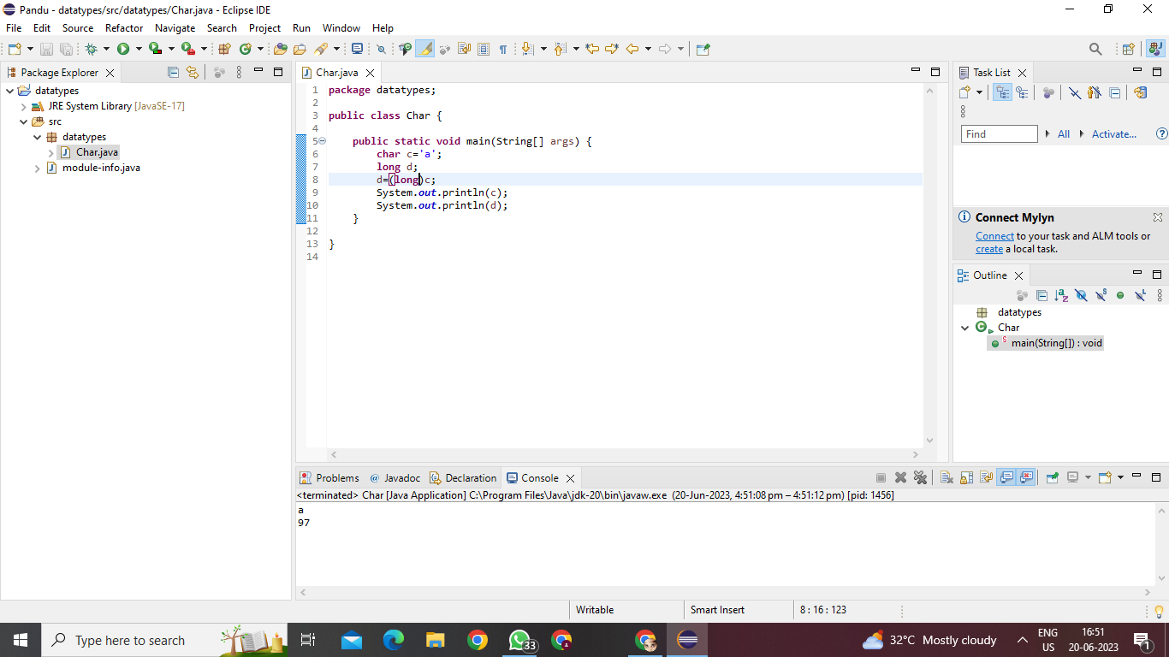

Explicit type casting

6. char to float

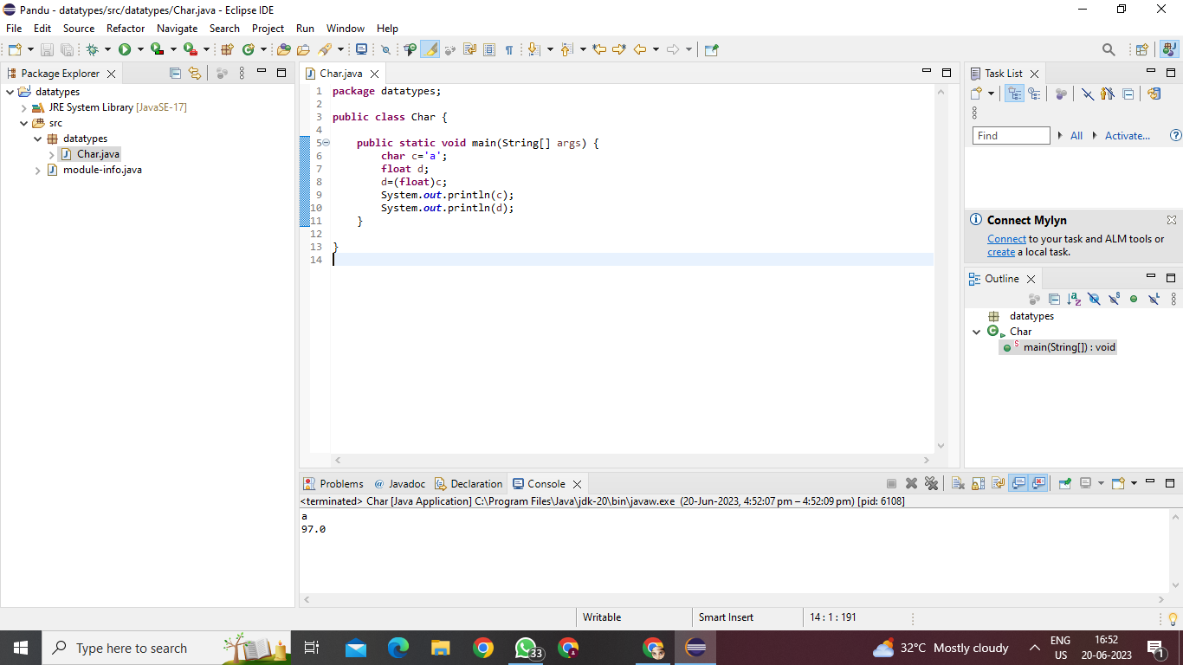

Explicit type casting

7. char to boolean

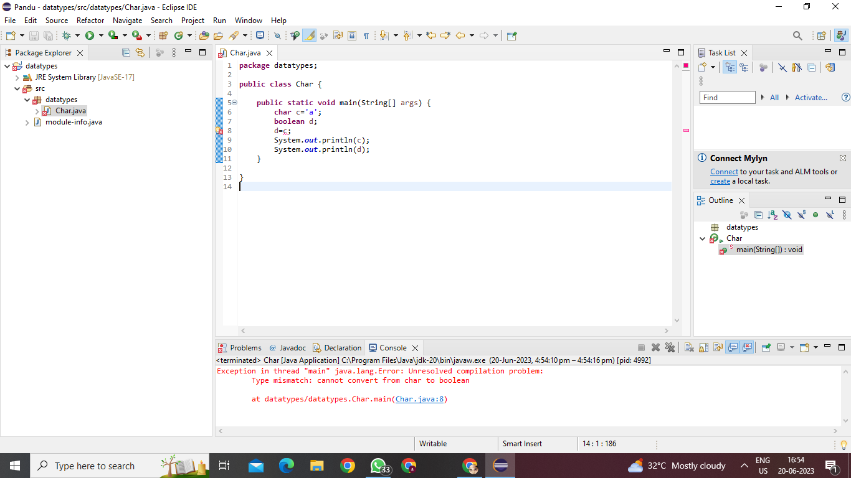

Not possible

1.byte to byte

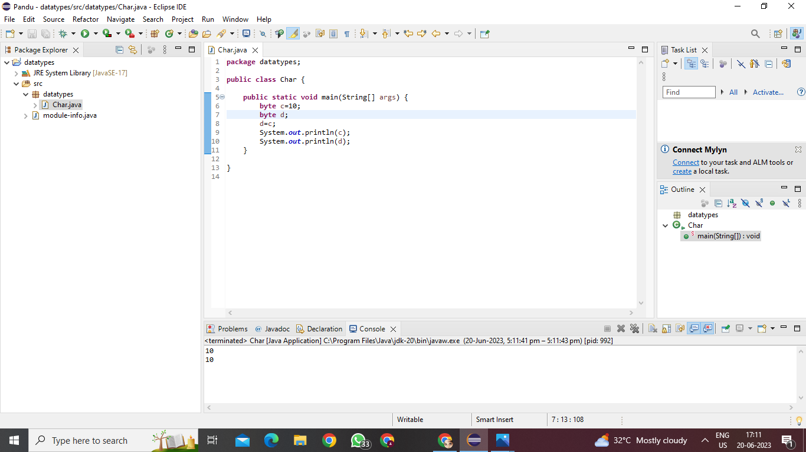

Casting not required

1. byte to char

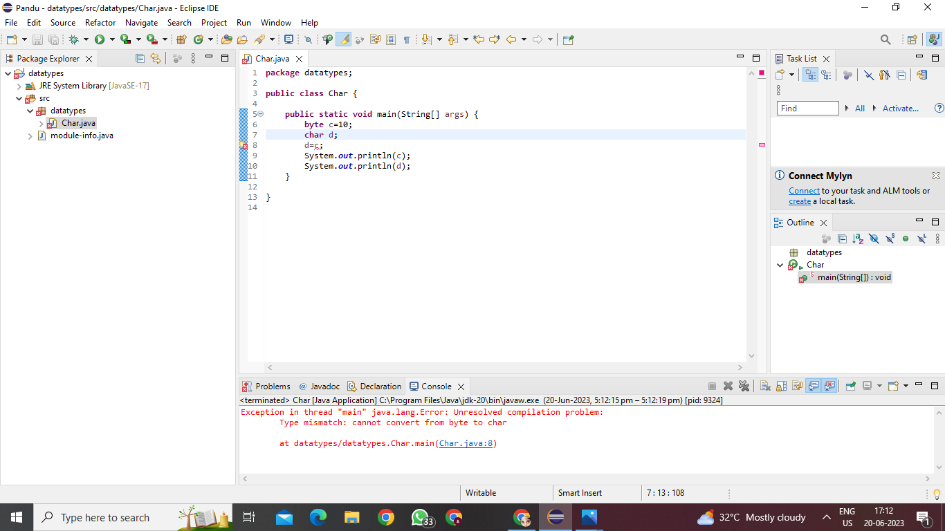

**Not possible**

1. byte to short

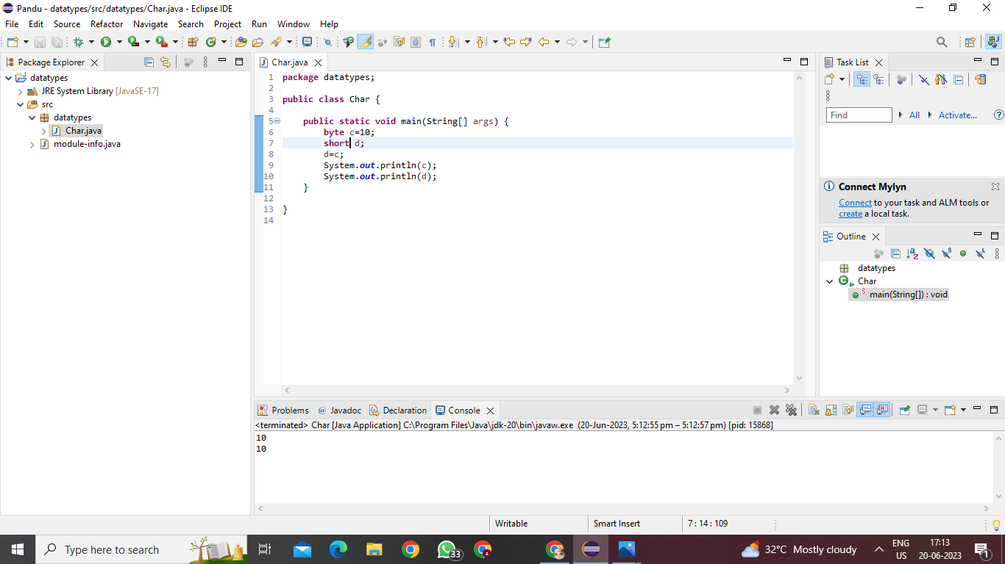

Implicit type casting

1. byte to int

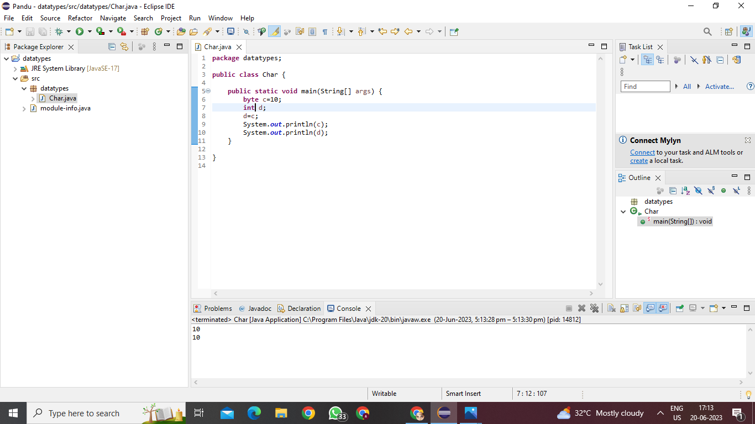

Implicit type casting

1. byte to long

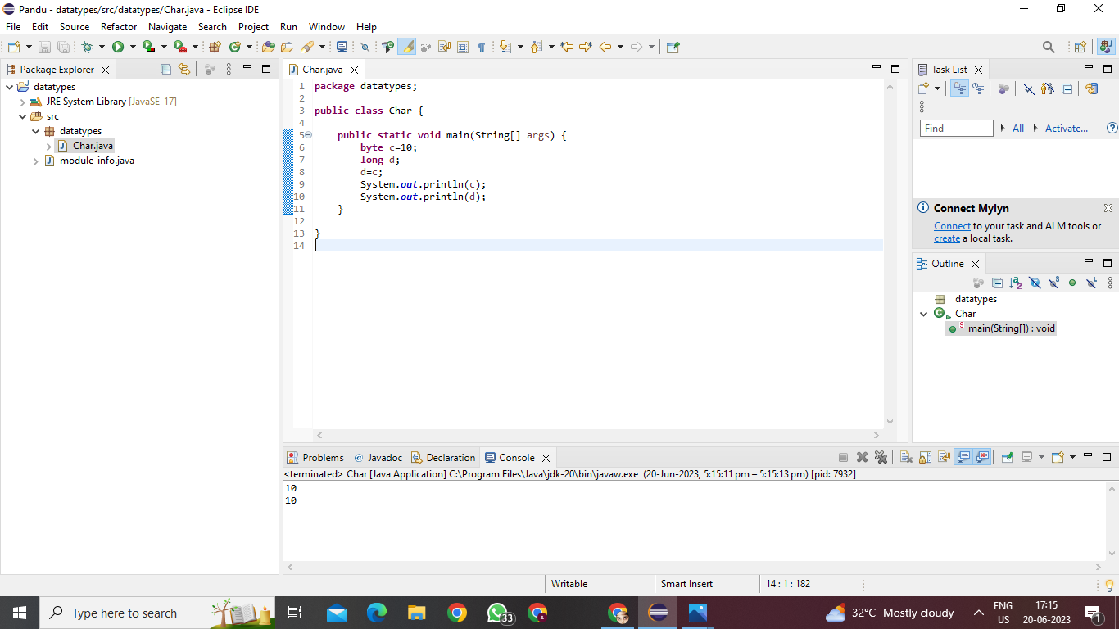

Implicit type casting

1. byte to float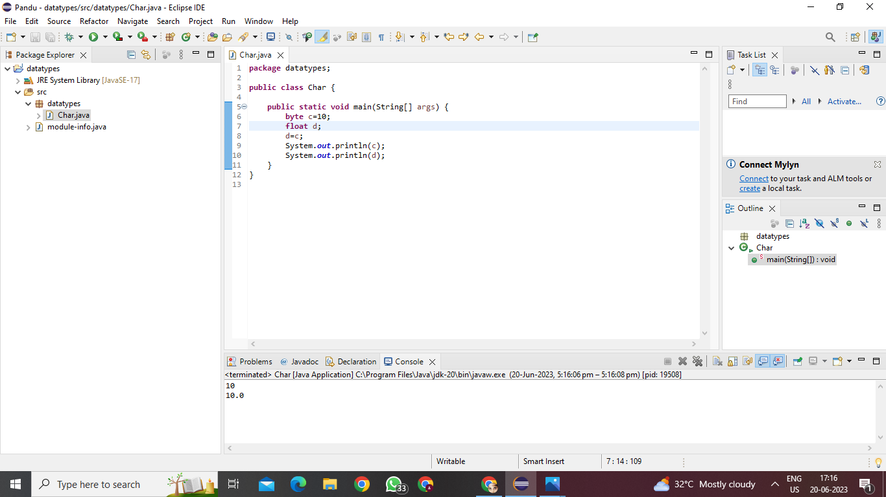

Implicit type casting7. Byte to double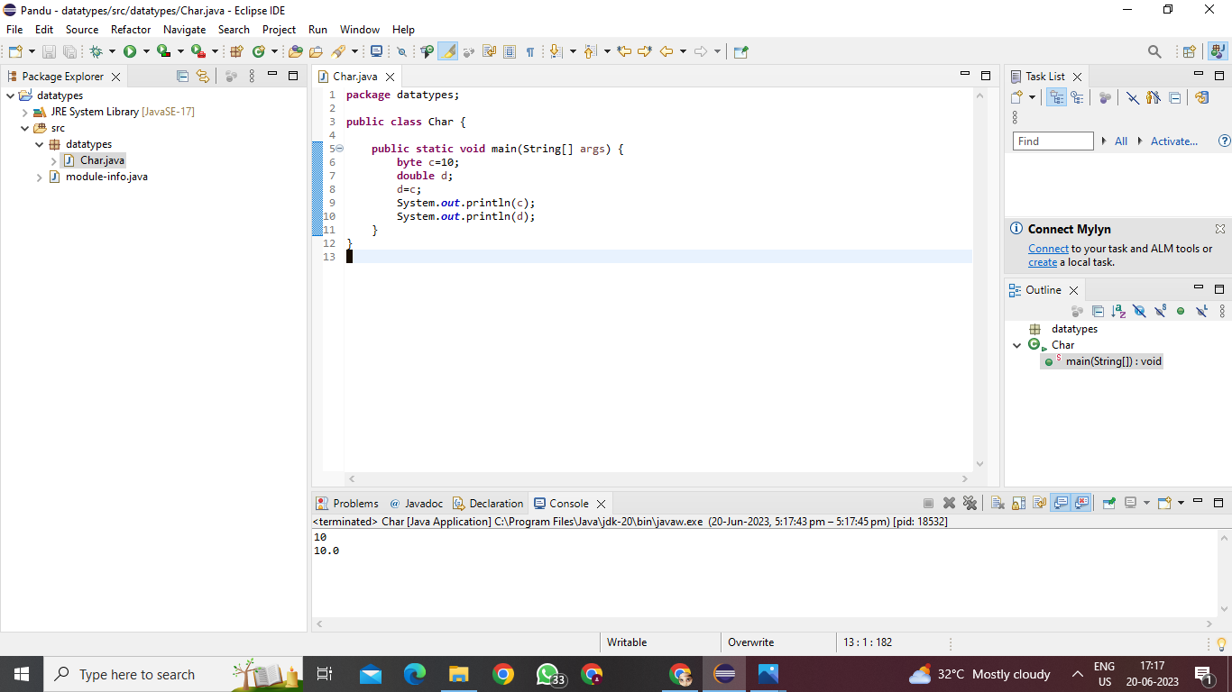

Implicit type casting

8.byte to boolean

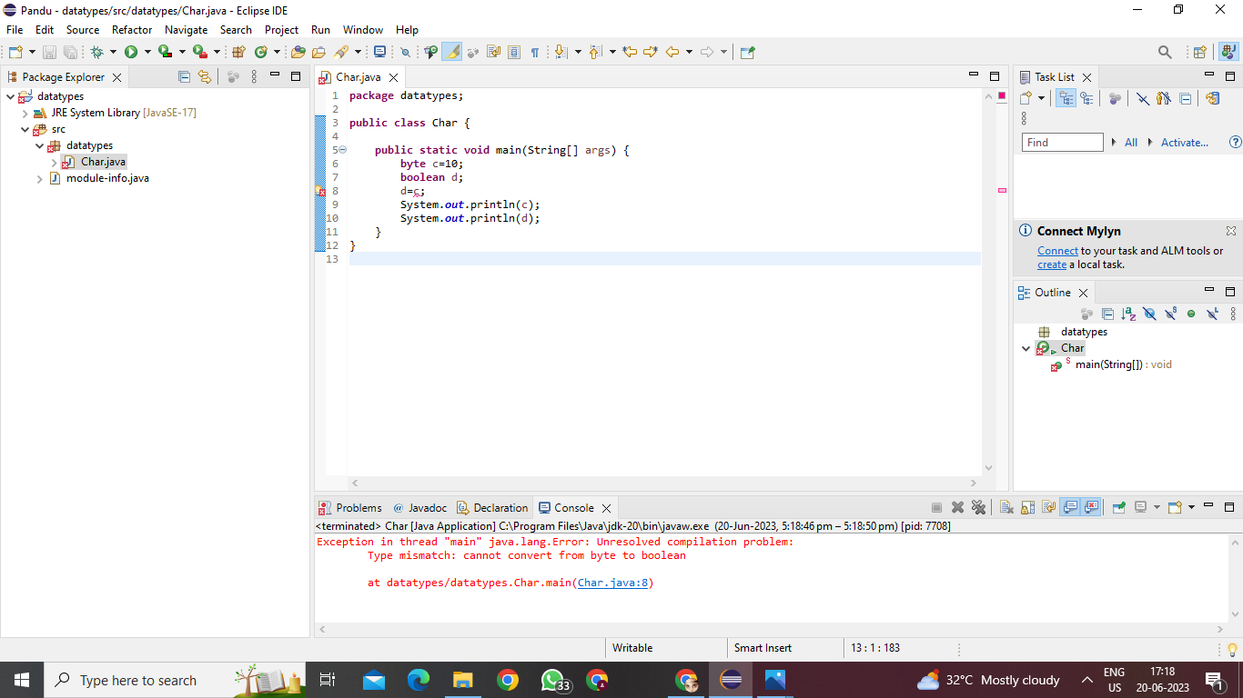

Not possible

1. short to char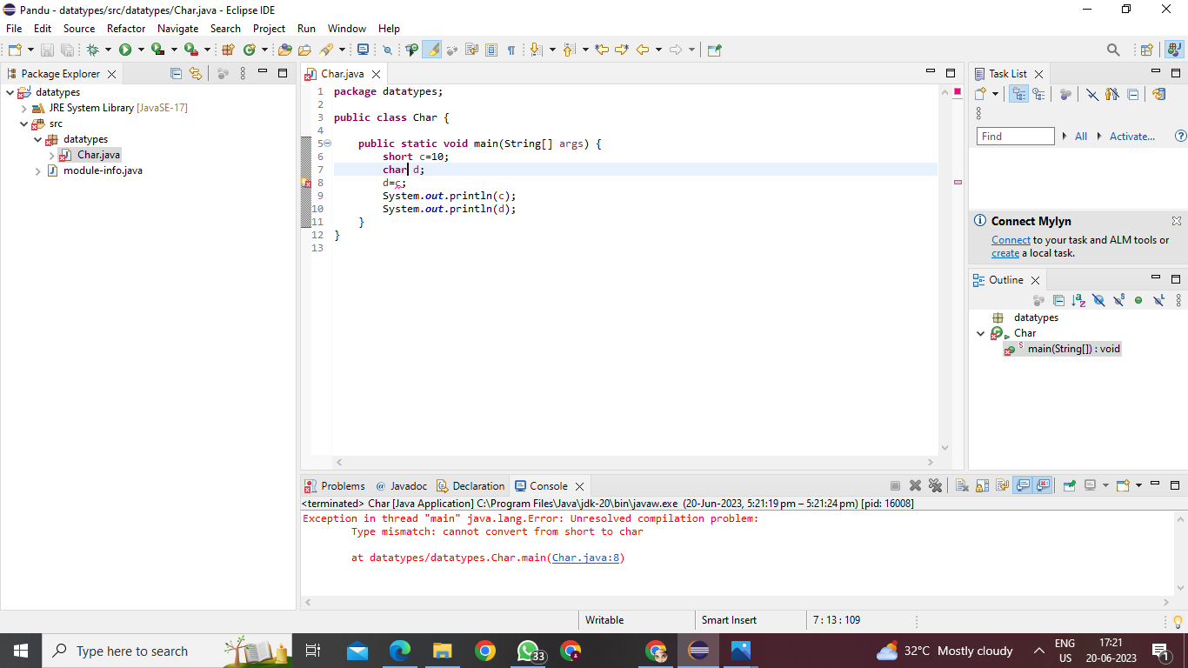

Not possible

2. short to byte

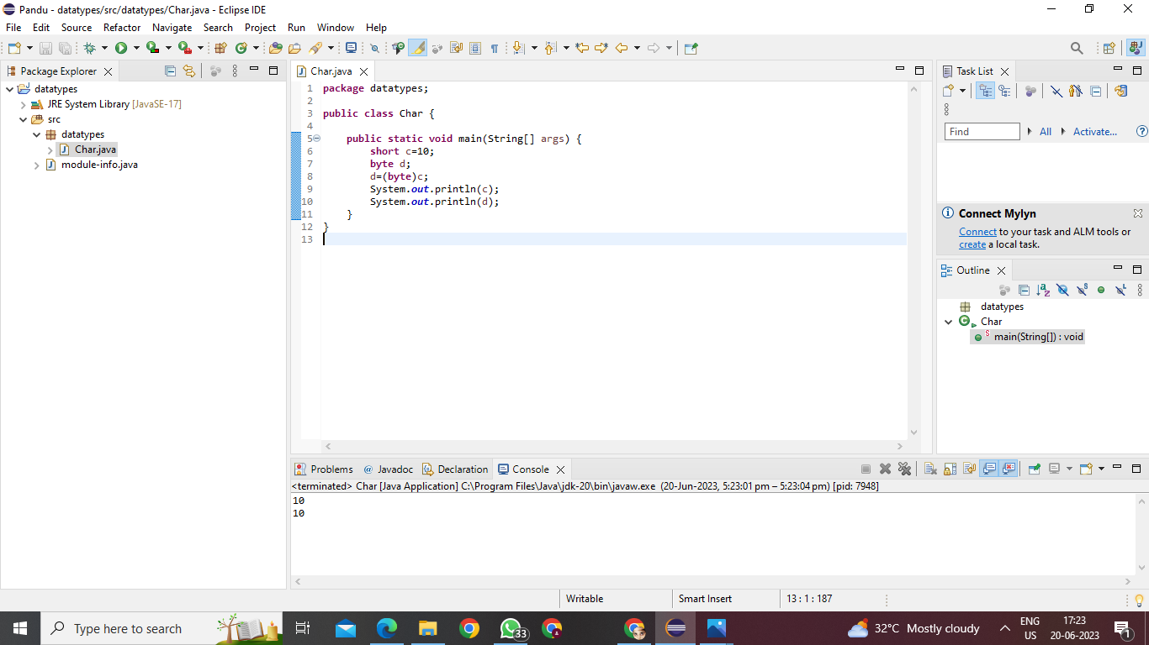

Explicit type casting

3. short to short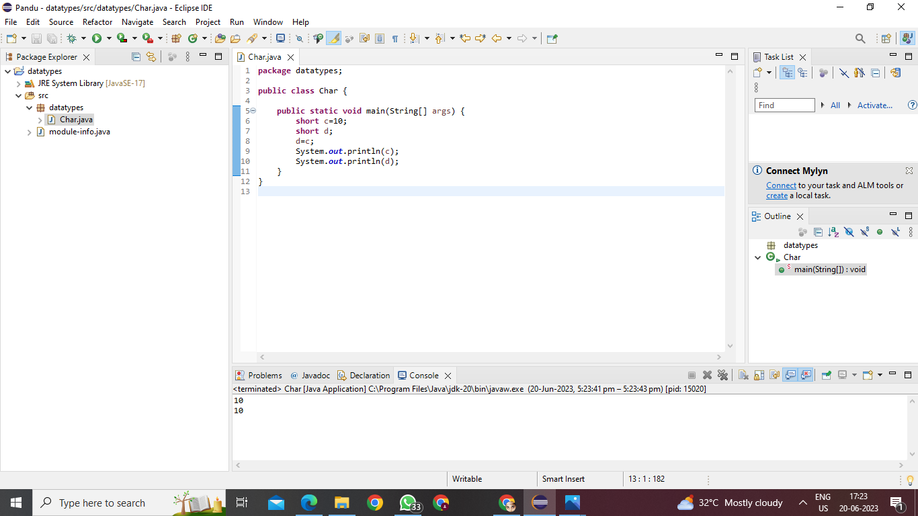

Casting not required

4. short to int

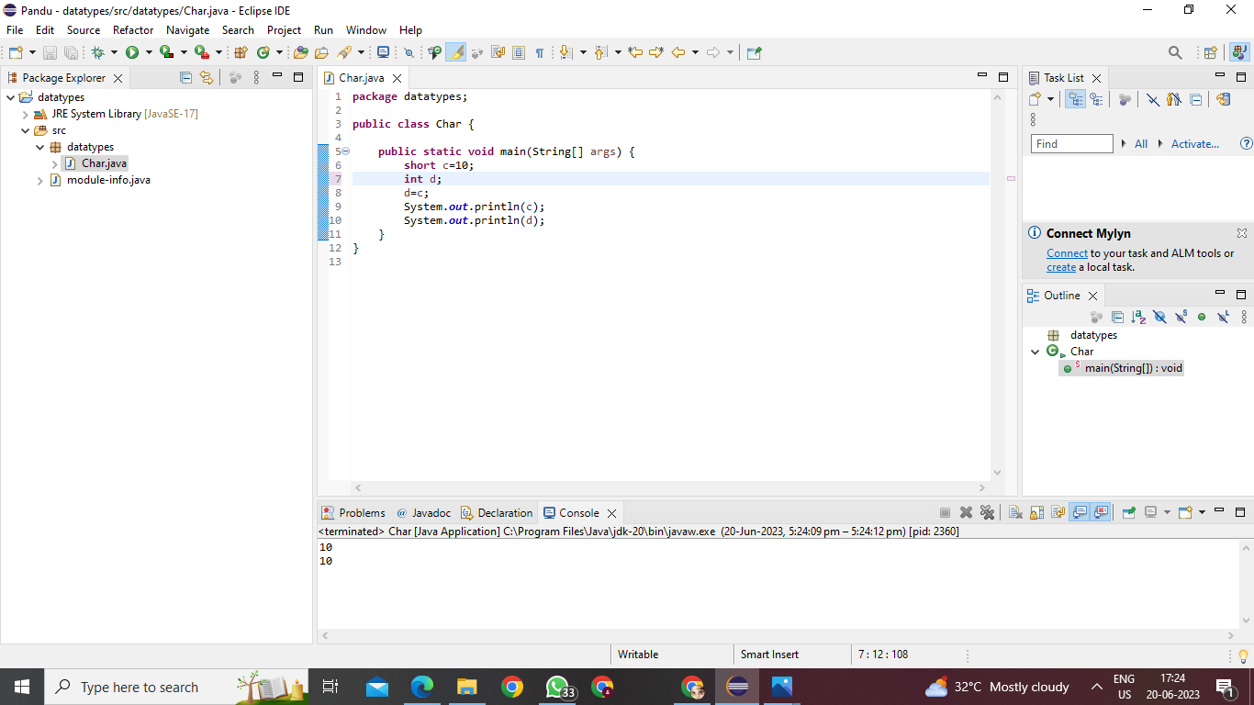

Implicit type casting

5. Short to long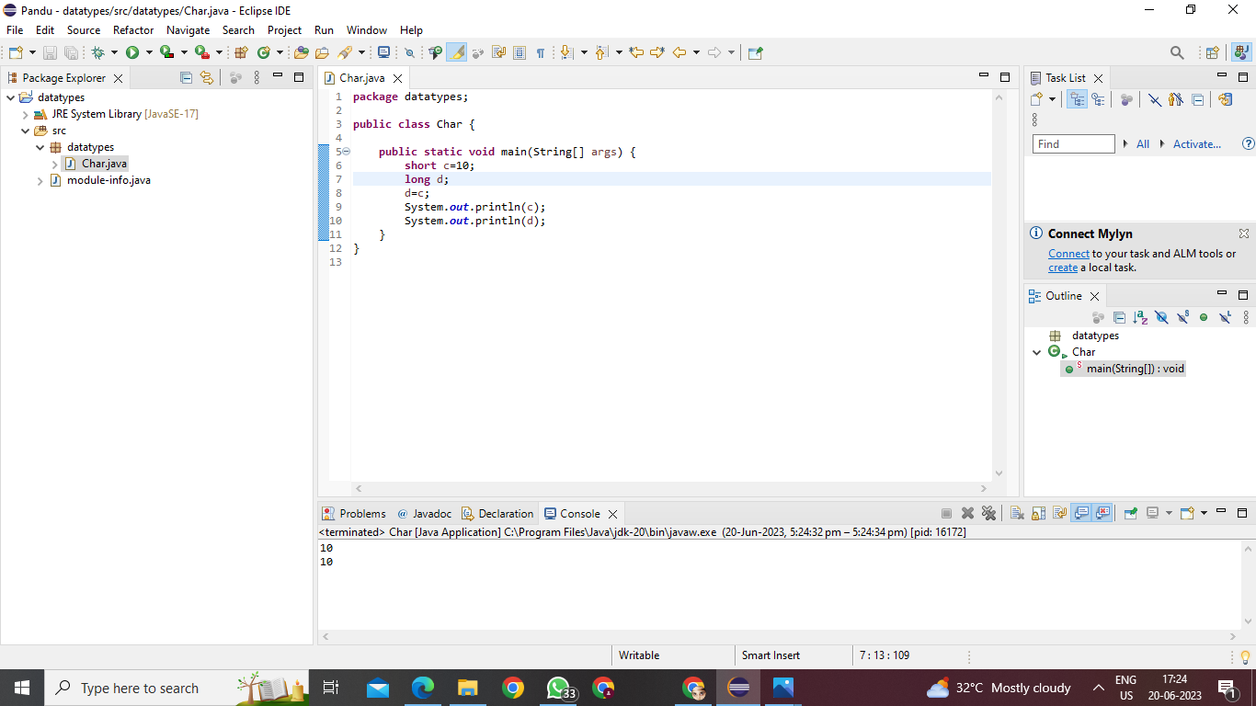

Implicit type casting

6.short to float

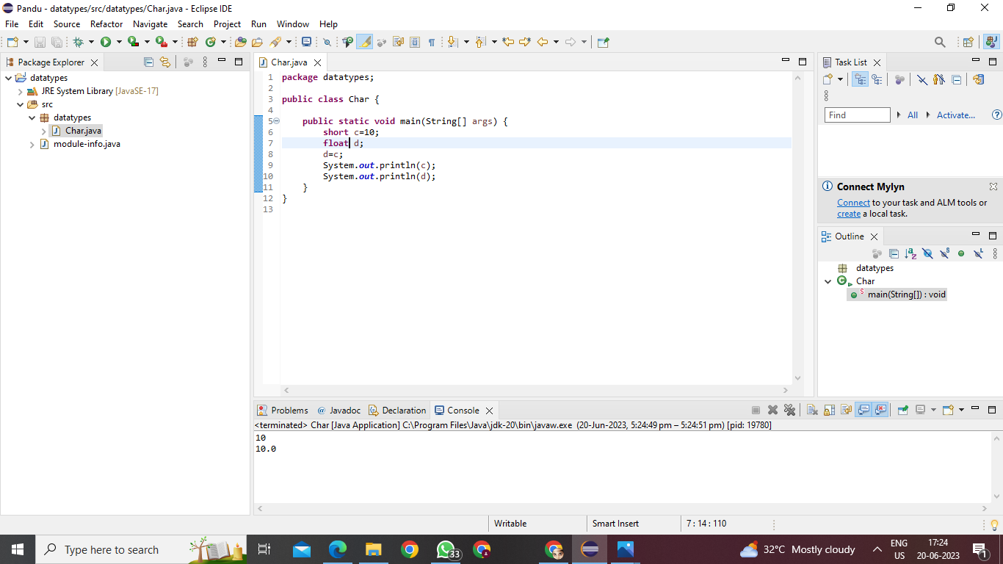

Implicit type casting

1. short to double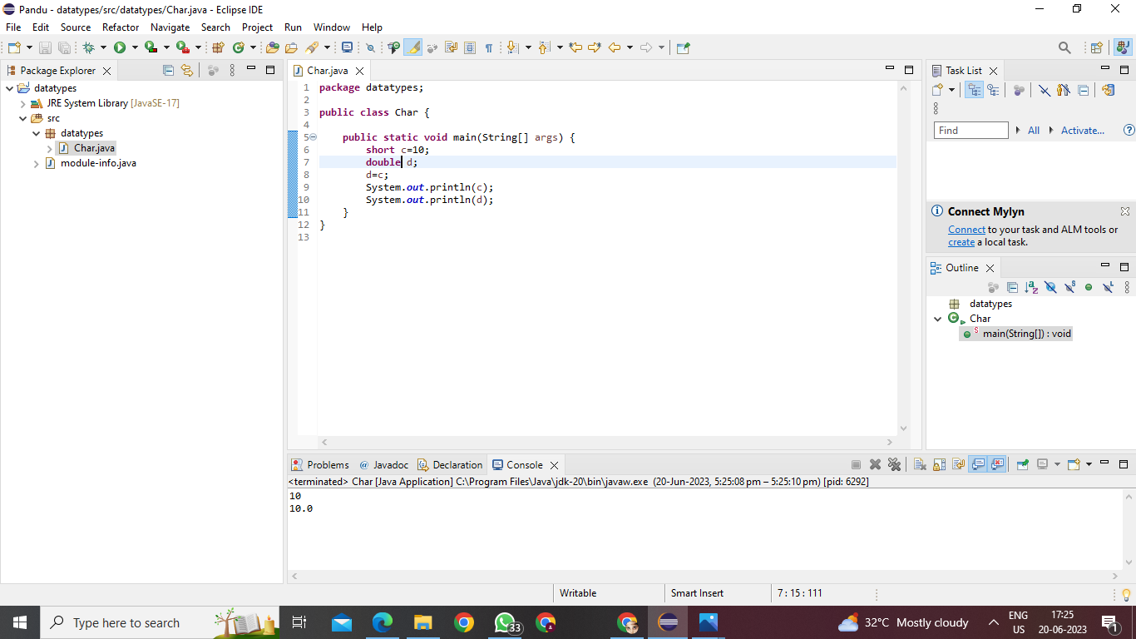

Implicit type casting

1. short to boolean

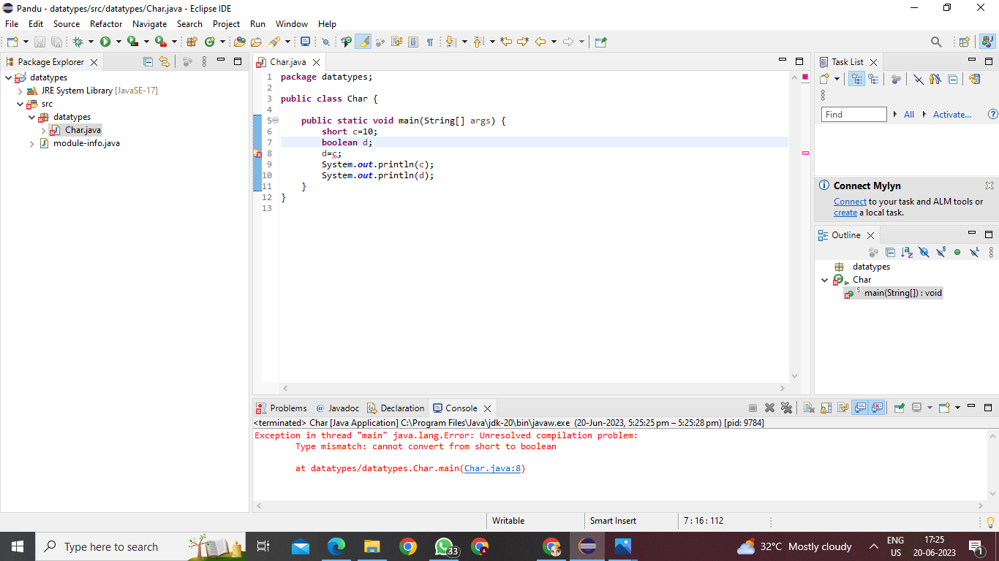

Not possible

1. int to char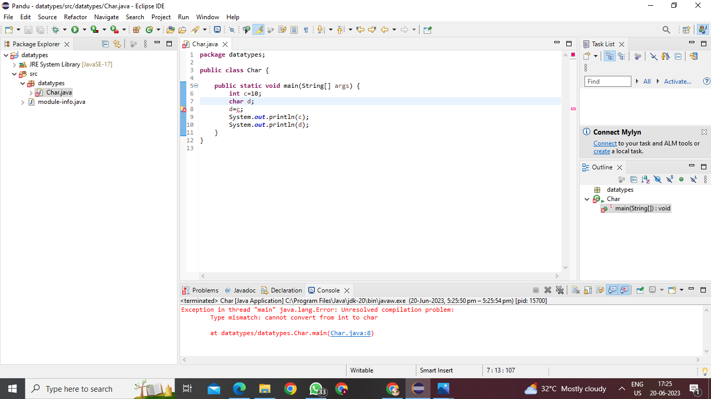

Not possible

1. int to byte

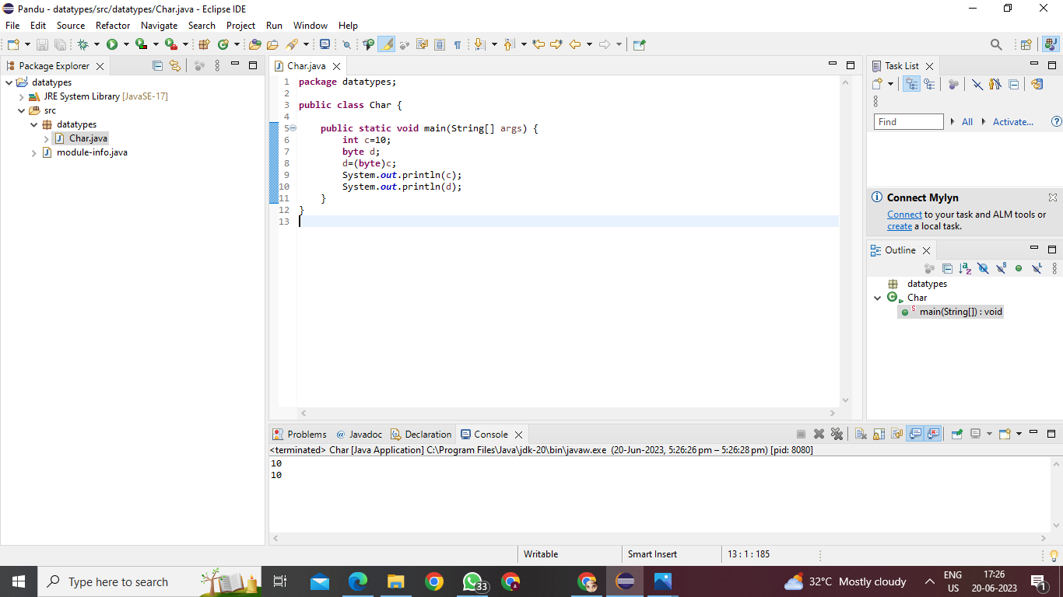

Explicit type casting

3.int to short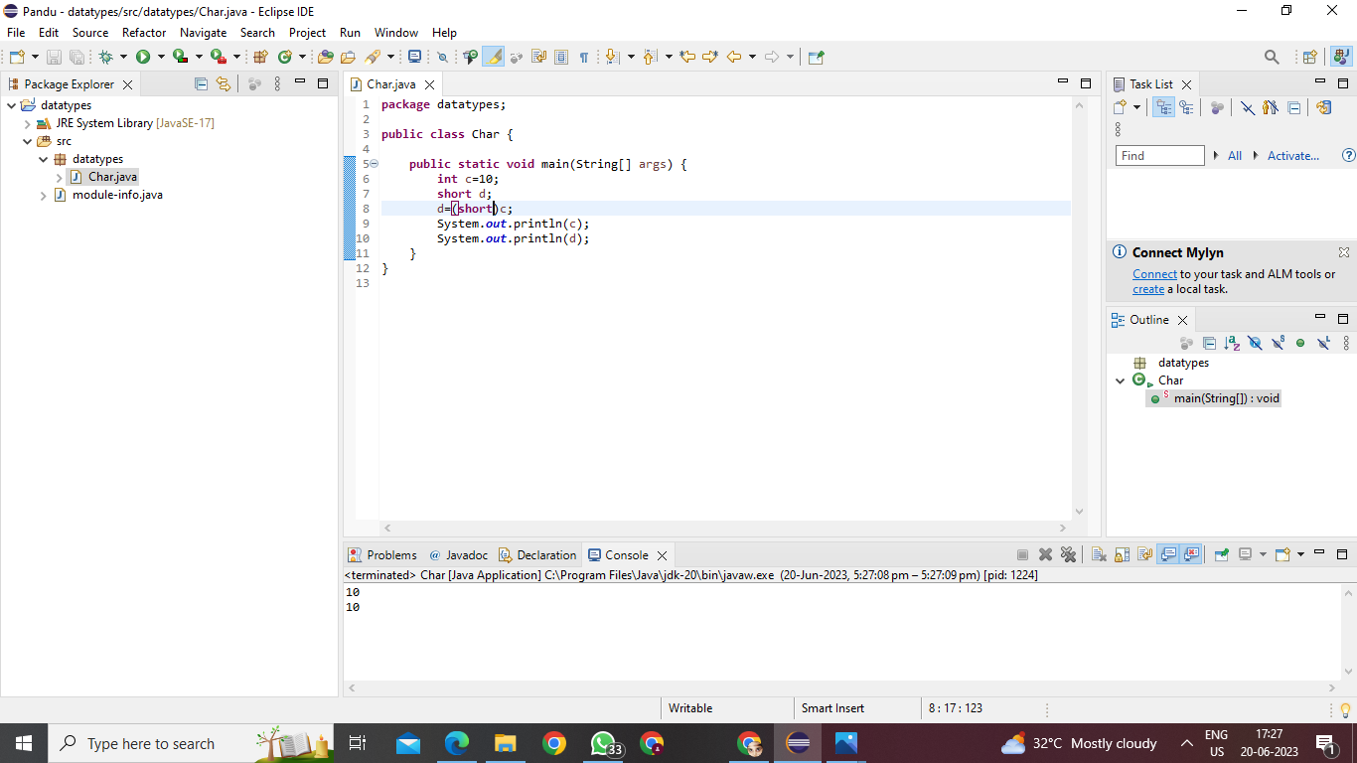

Explicit type casting

4.int to int

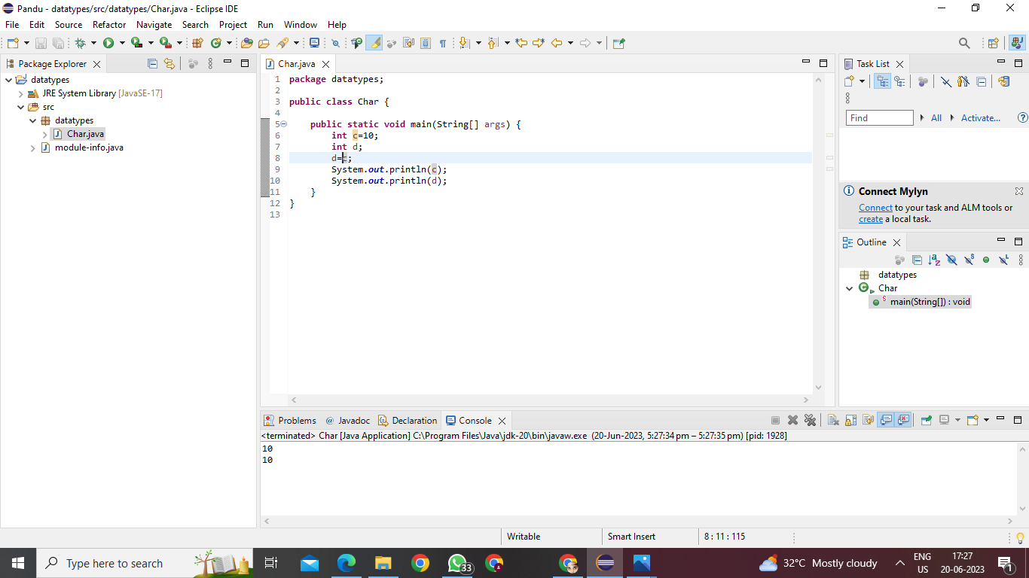

Casting not required

5.int to double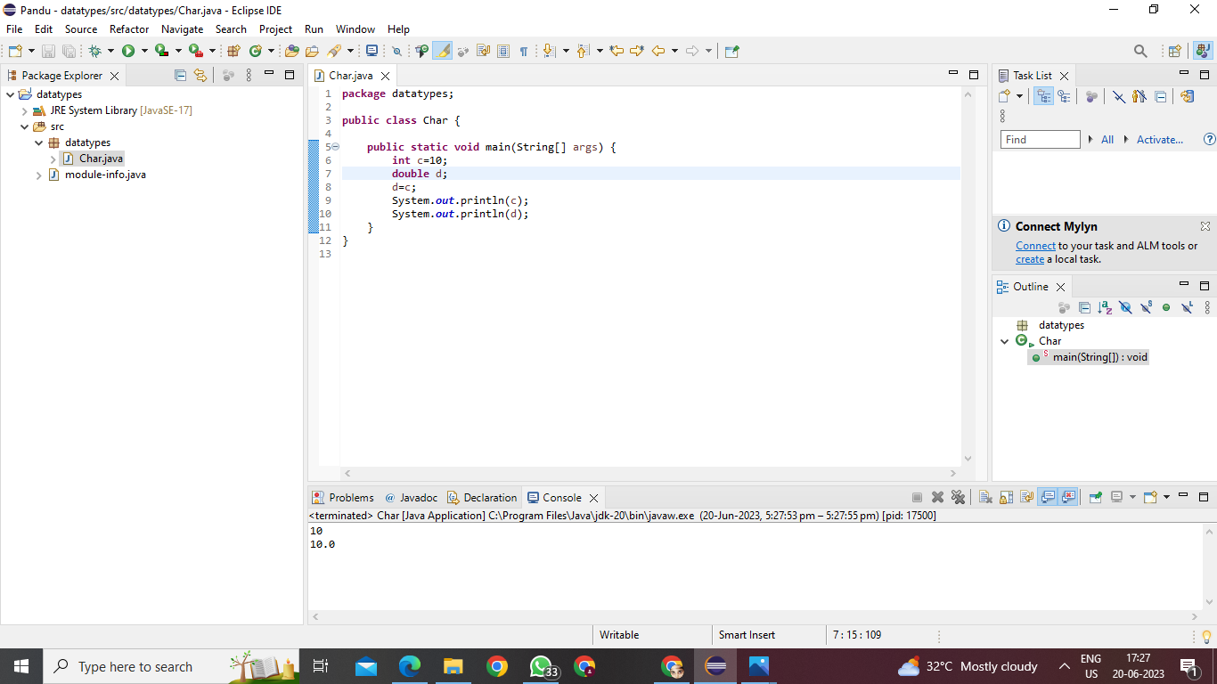

Implicit type casting

6. int to float

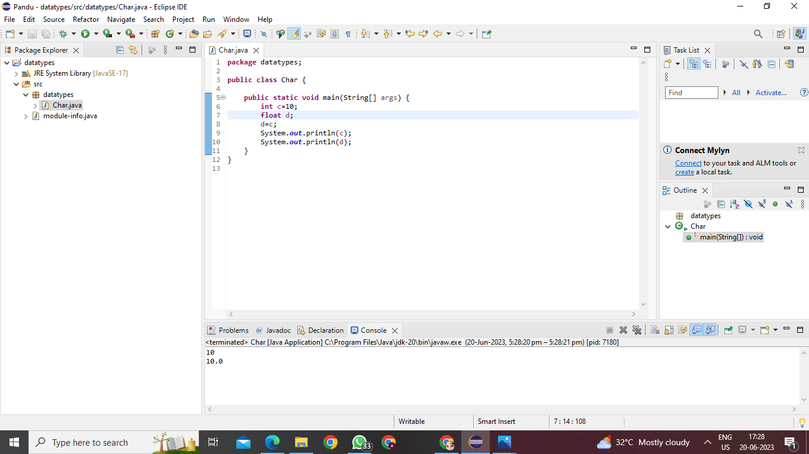

Implicit type casting

7.int to long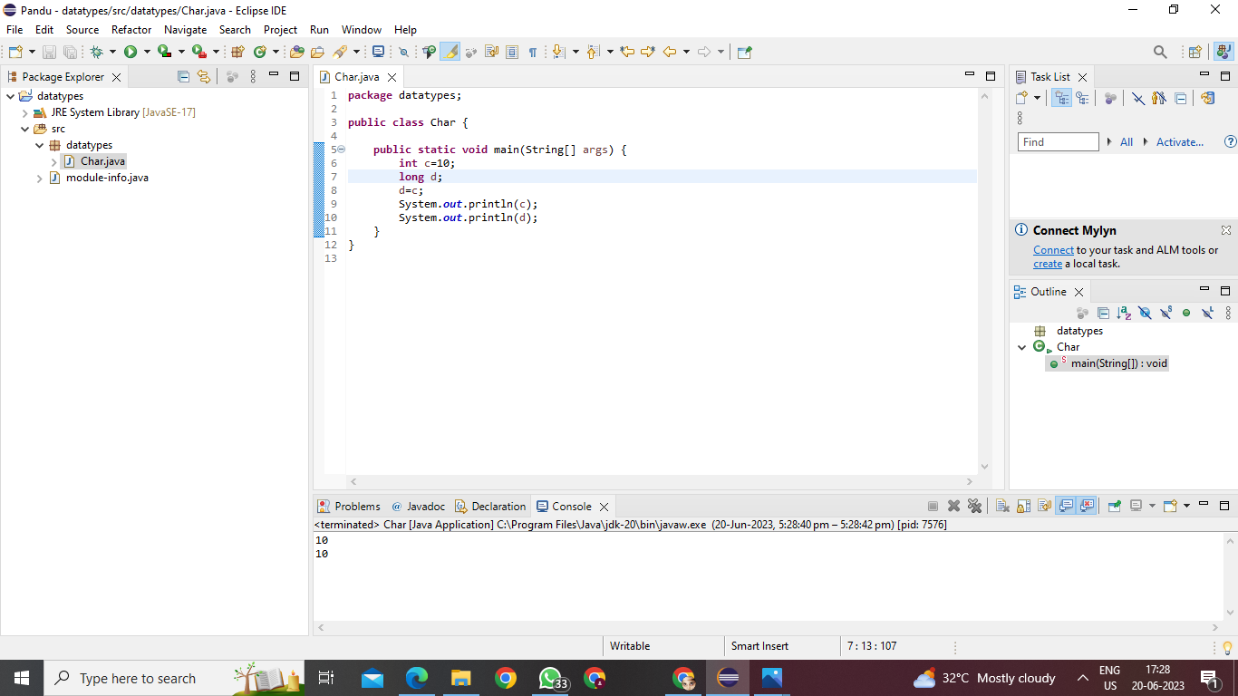

Implicit type casting

8.int to boolean

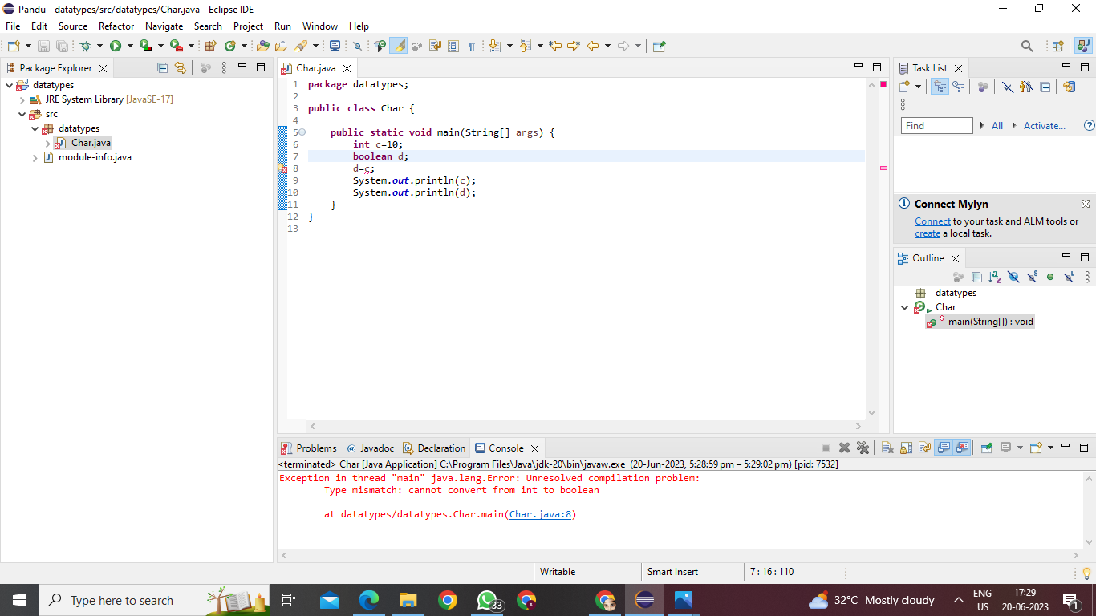

Not possible

1.long to char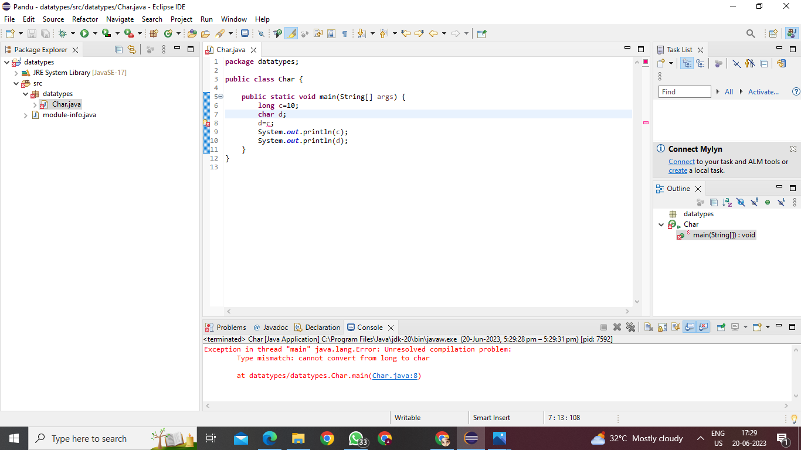

Not possible

2.long to long

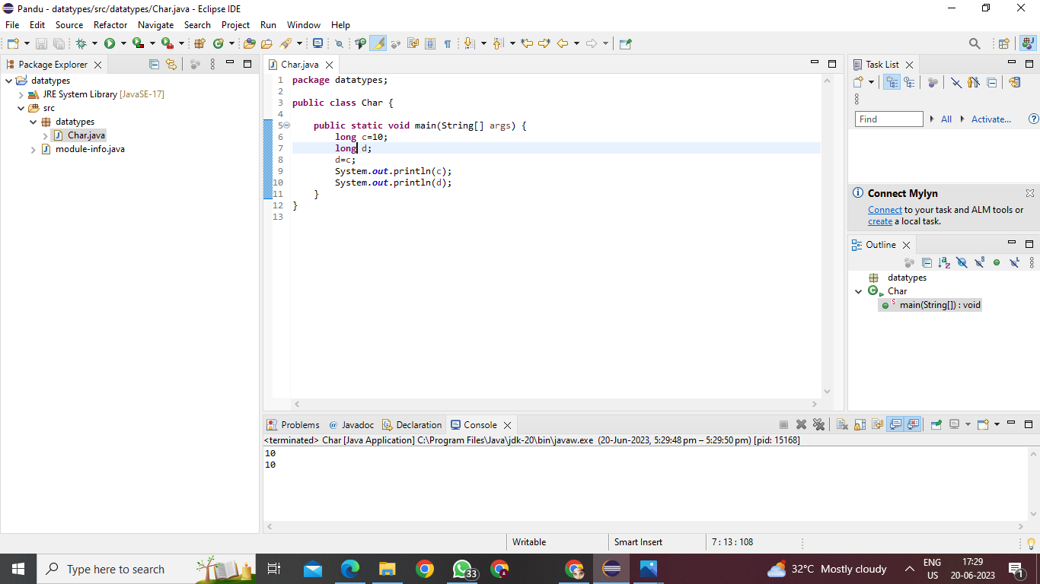

Casting not required

3.long to double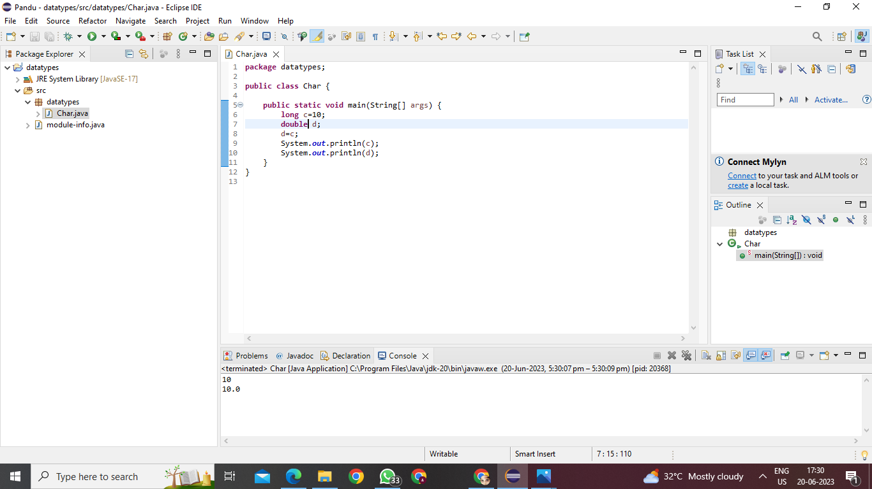

Explicit type casting

4.long to float

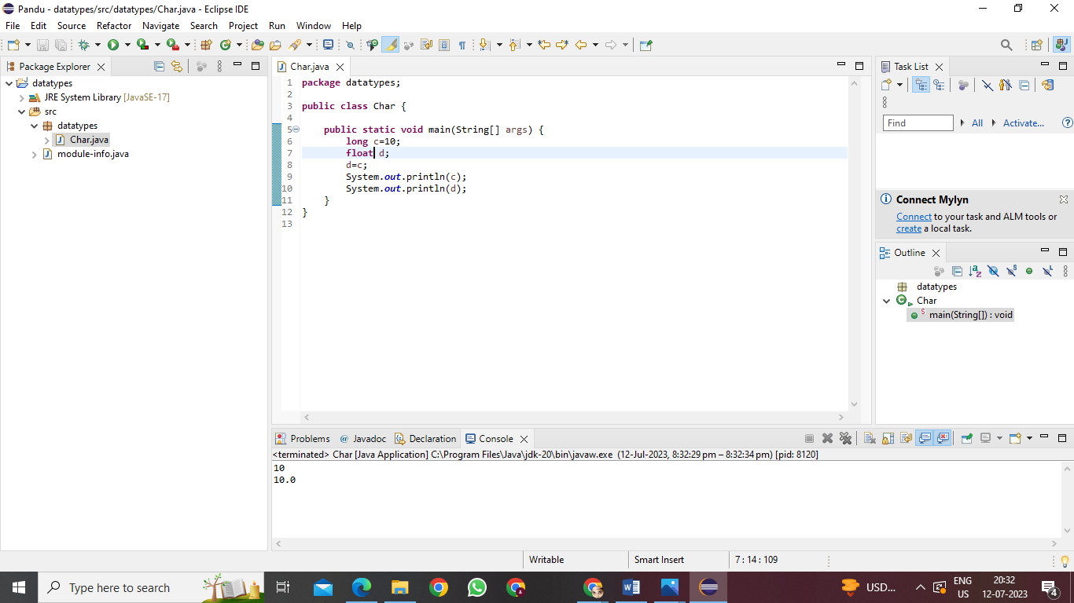

Explicit type casting

5.long to byte

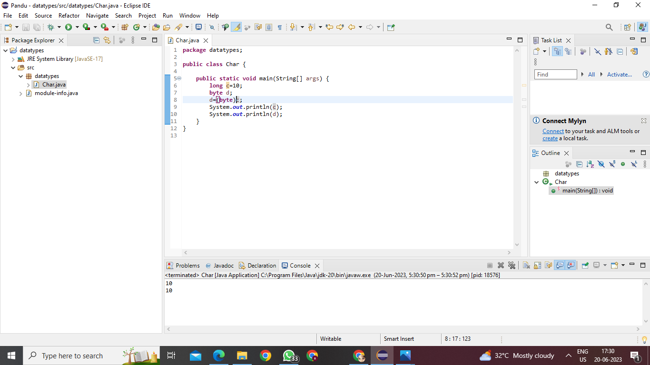

Implicit type casting6. long to short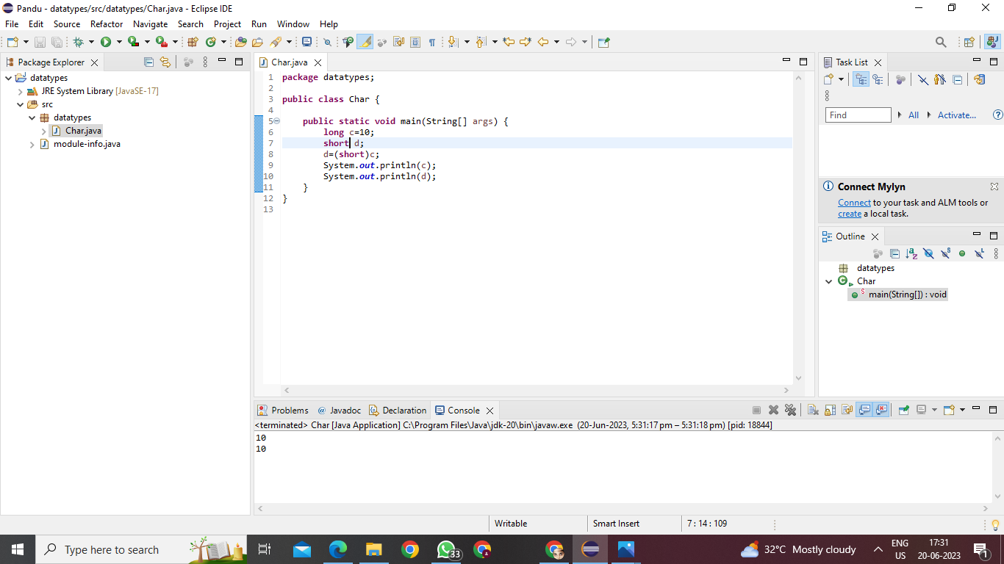

Explicit type casting

7. long to int

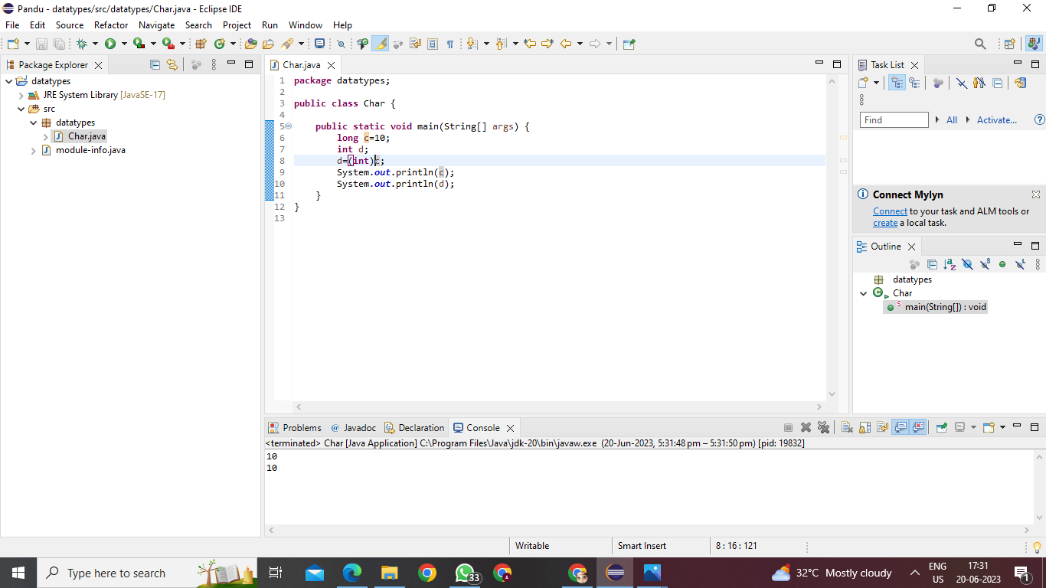

Explicit type casting

8.long to boolean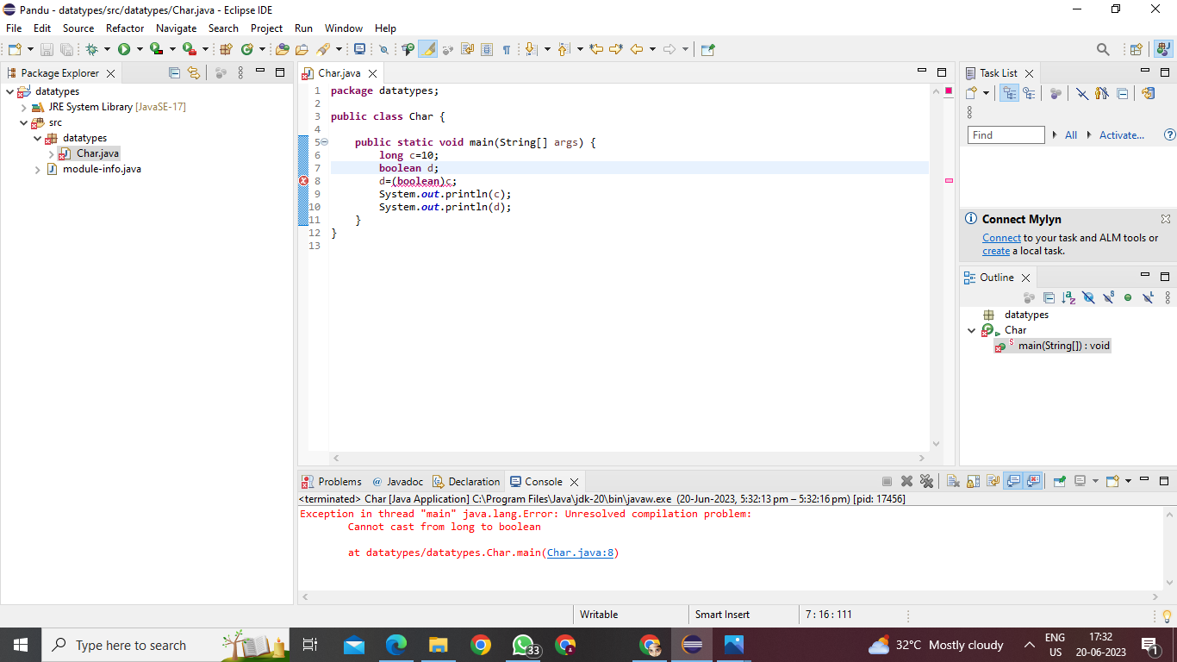

Not possible

1.float to byte

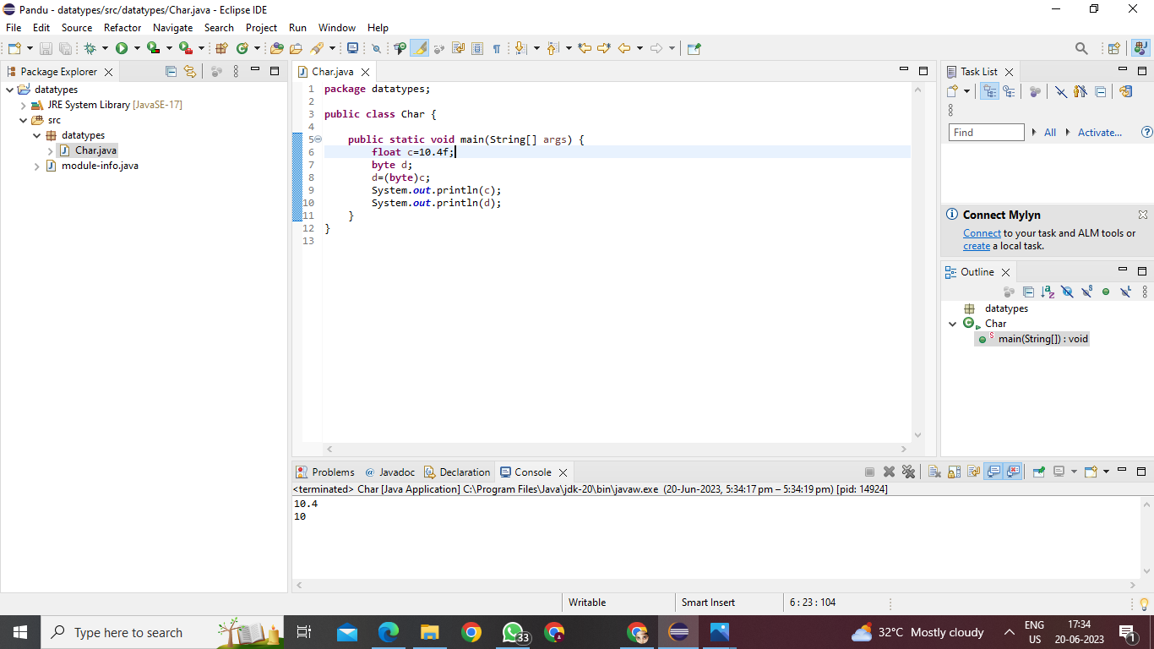

2.float to char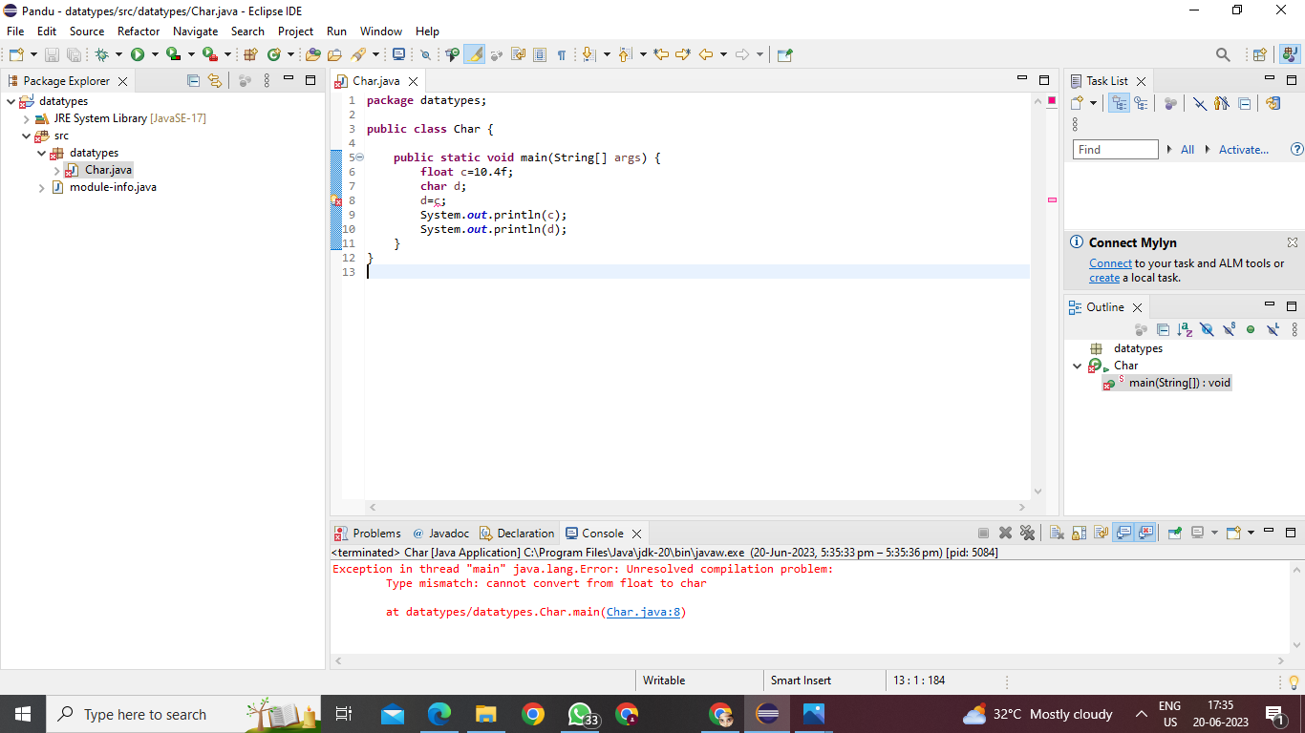

3. float to short

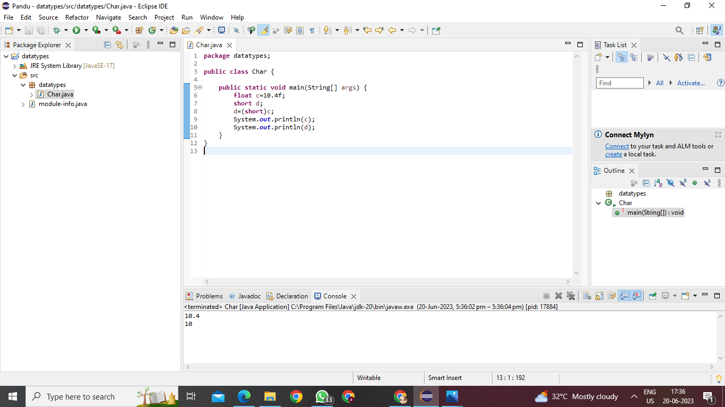

Explicit type casting

4.float to int

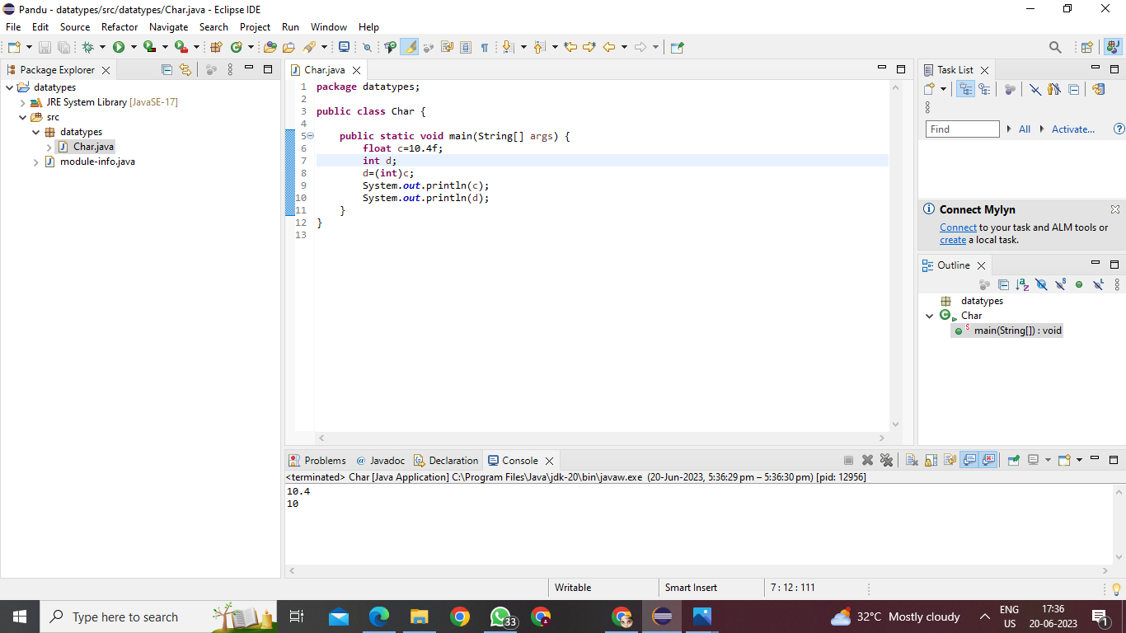

Explicit type casting

5.float to long

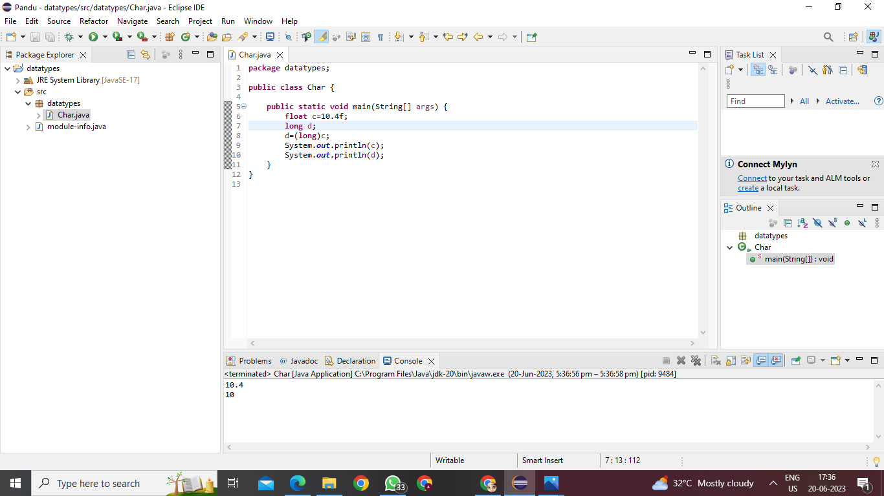

Explicit type casting

**6.float to float**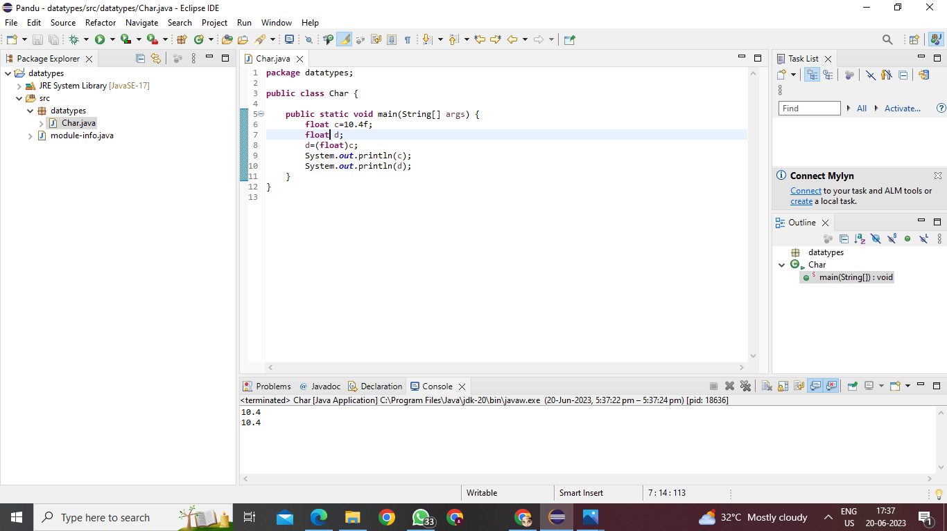

Explicit type casting

7.float to double

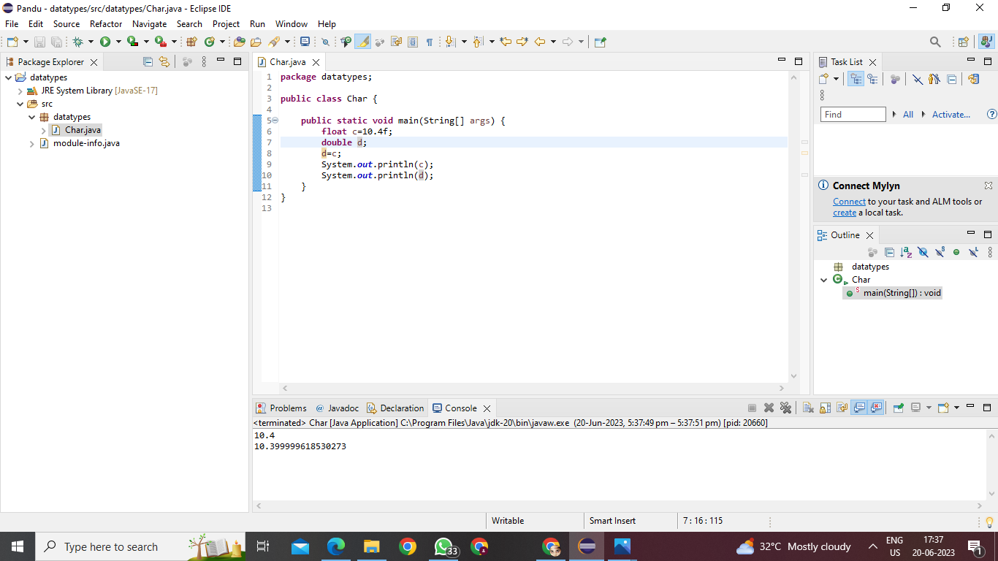

Implicit type casting

**8.**float to boolean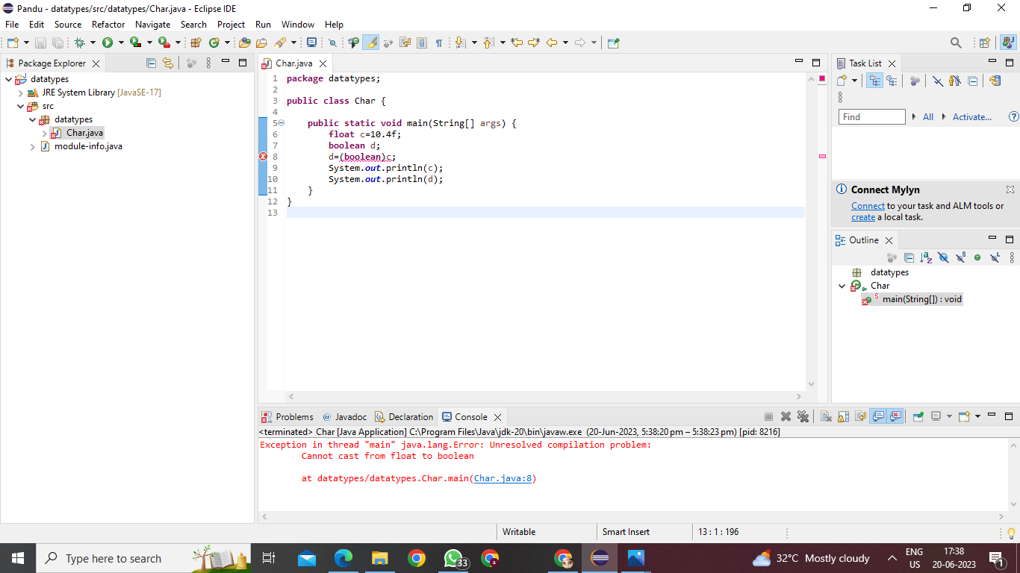

Not possible

1.double to char

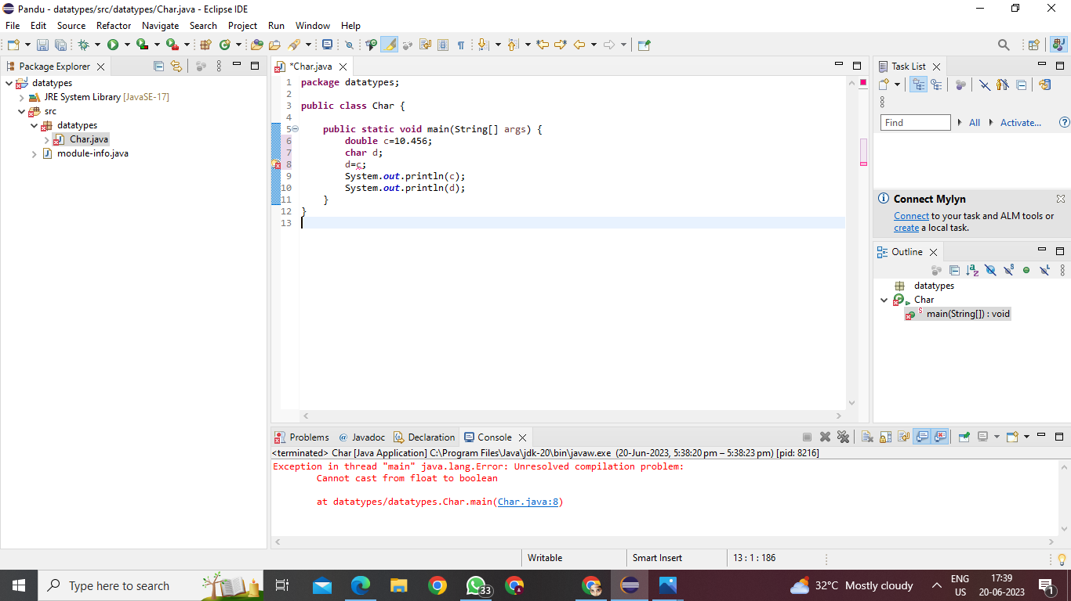

Not possible

2.double to byte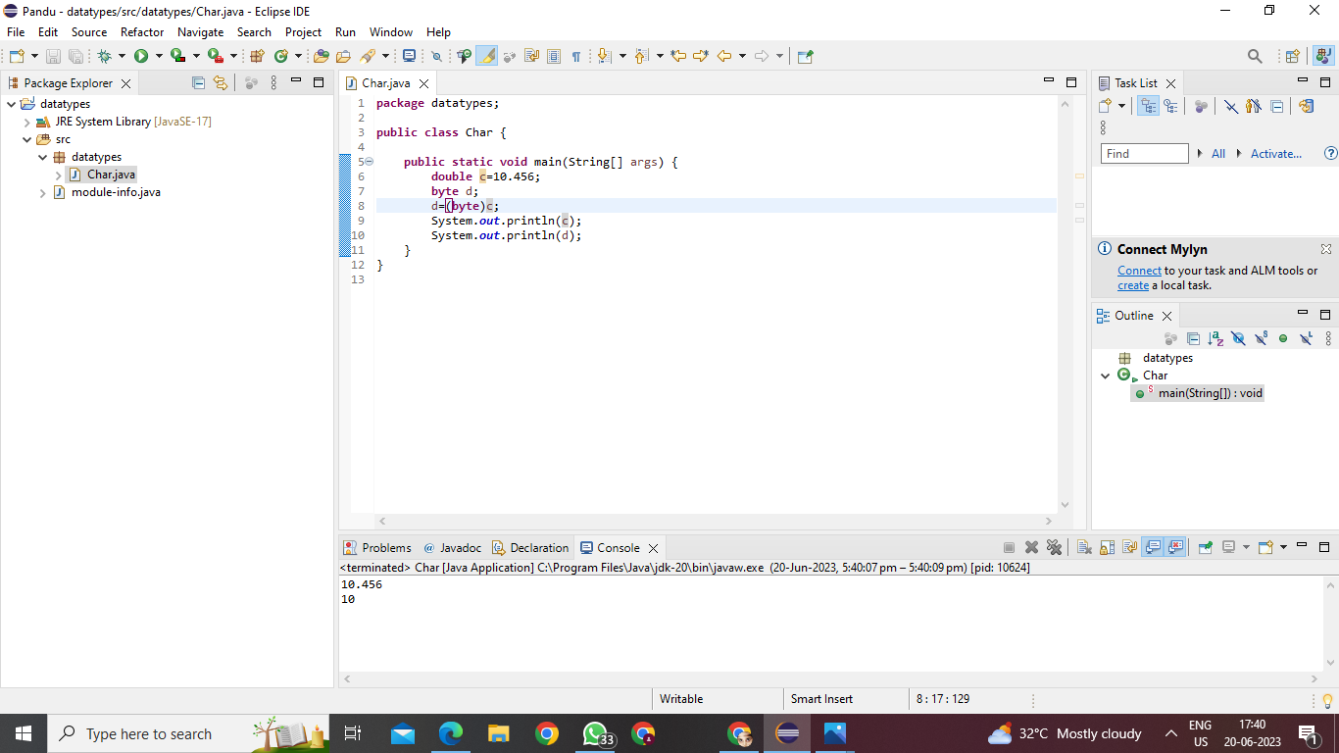

Explicit type casting

3.double to short

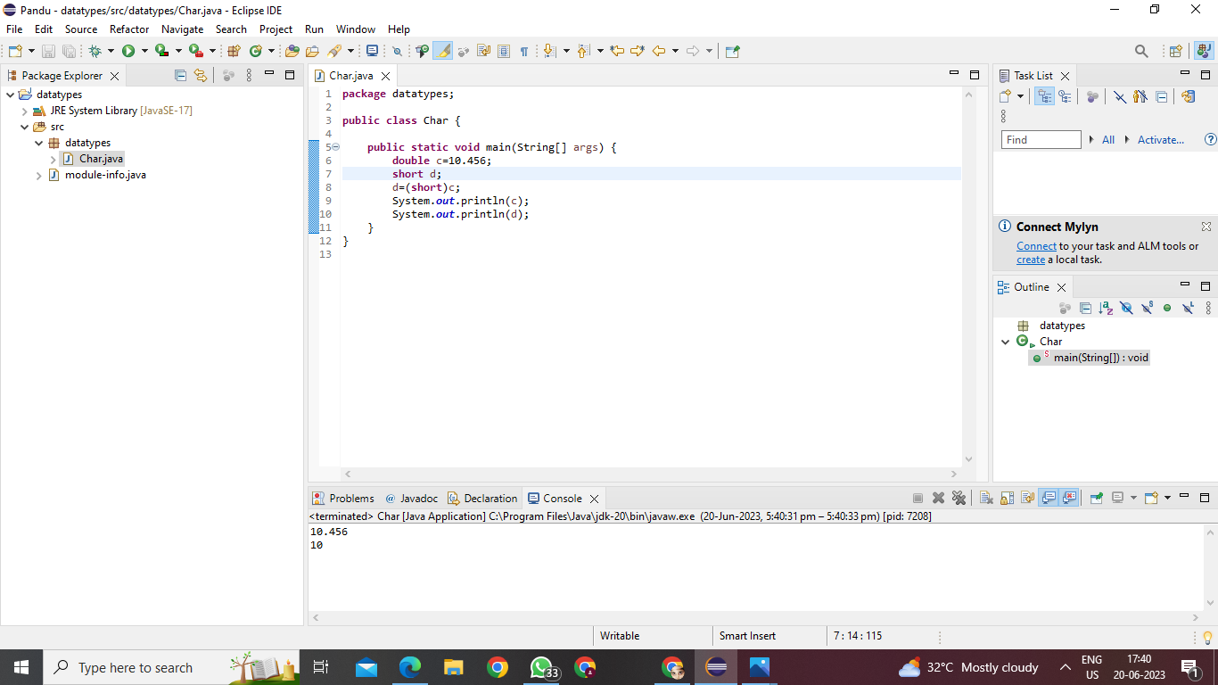

**Explicit type casting**

4.double to int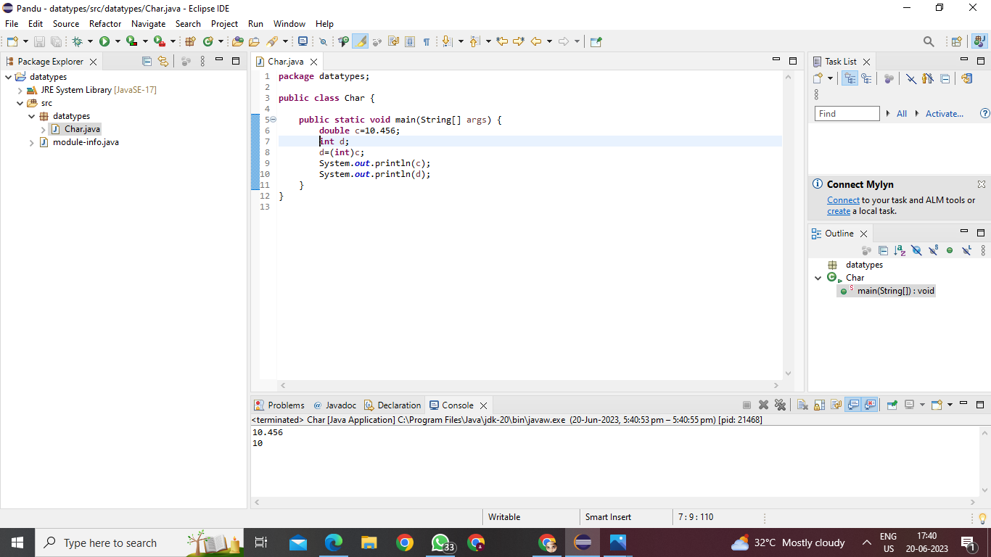

Explicit type casting

5. double to long

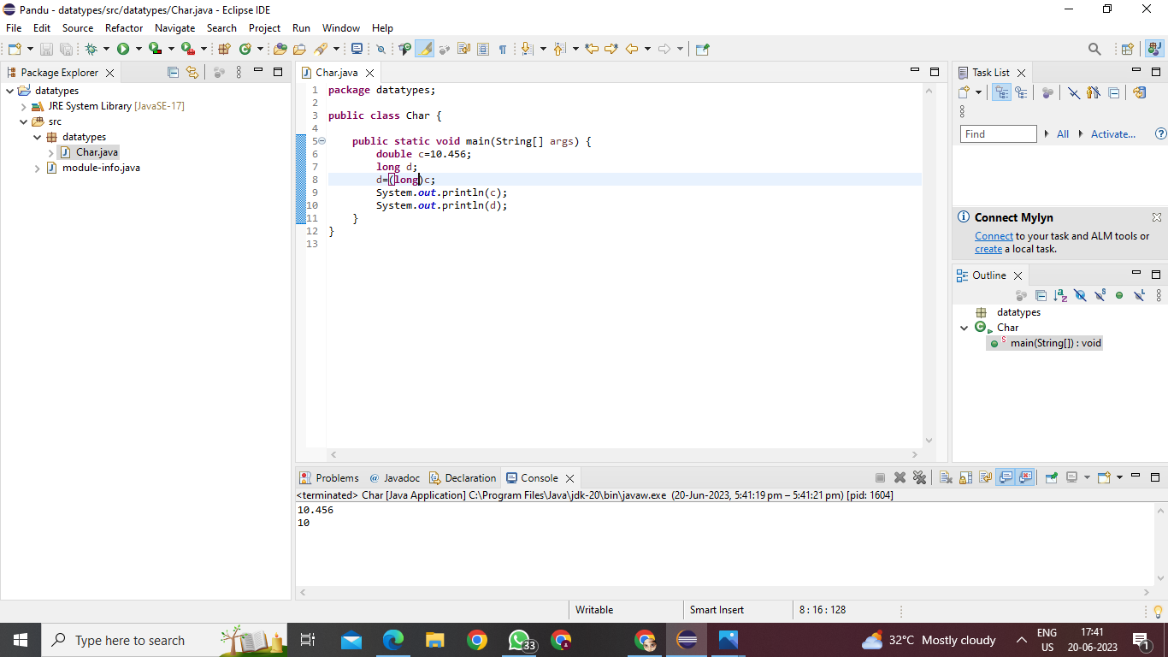

Explicit type casting

6.float to double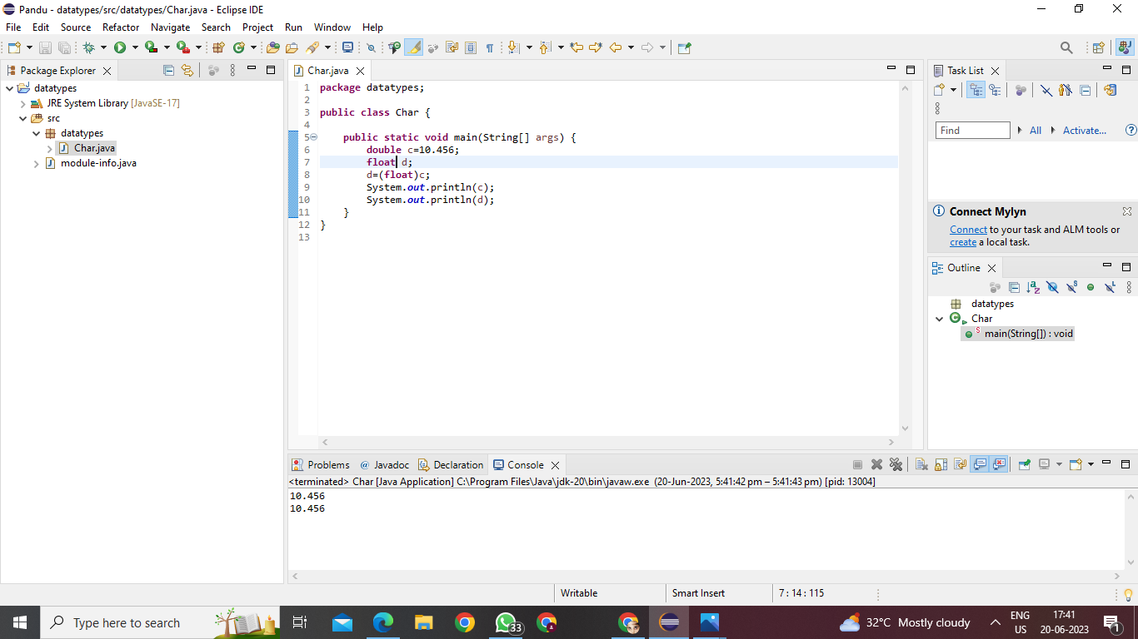

Explicit type casting

7.double to double

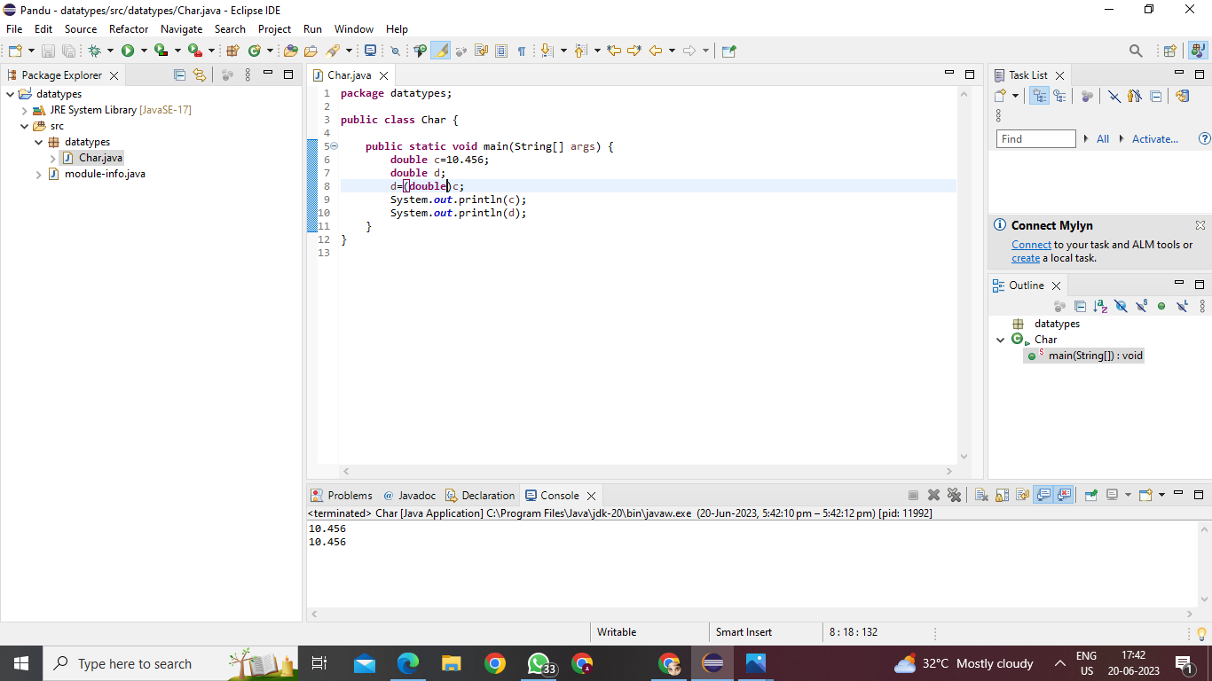

Explicit type casting

8.double to boolean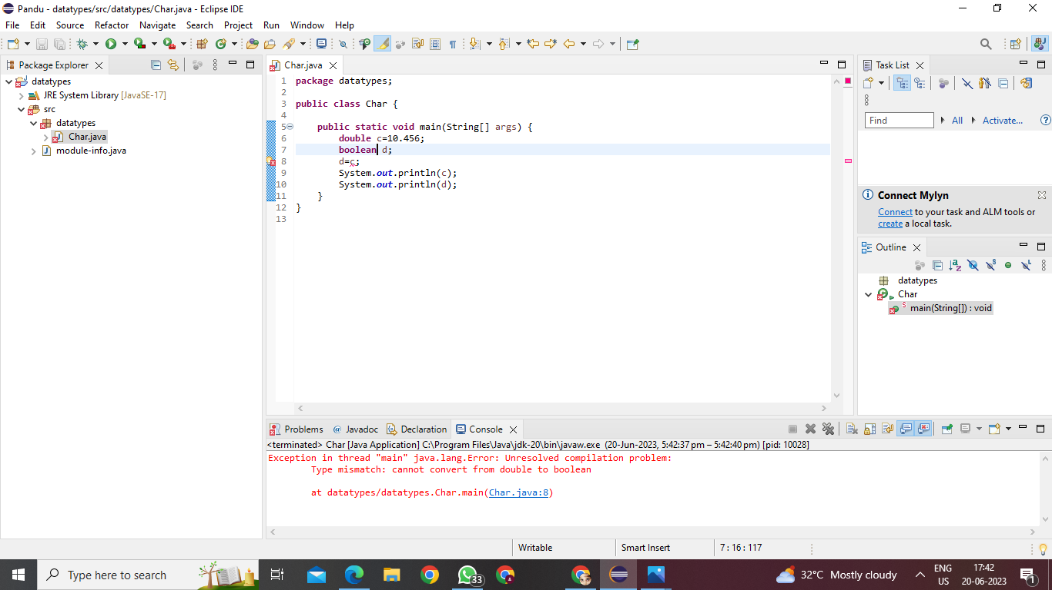

Not possible

1.boolean to char

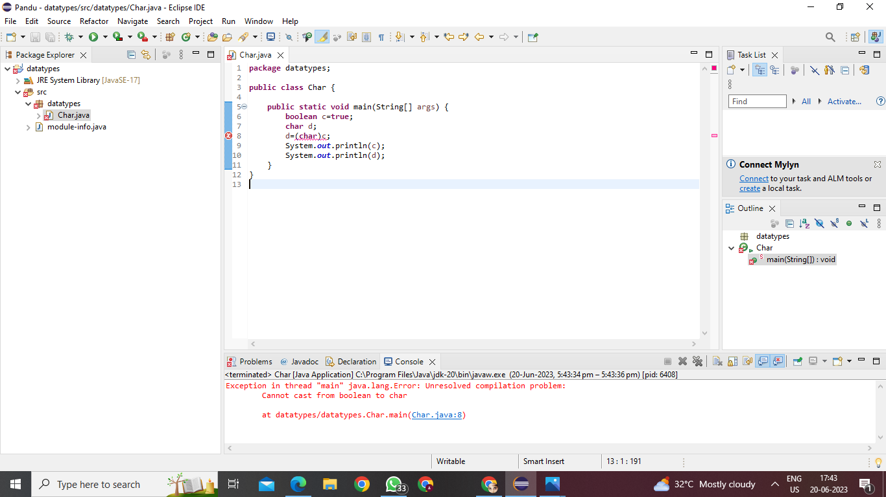

Not possible

2.boolean to byte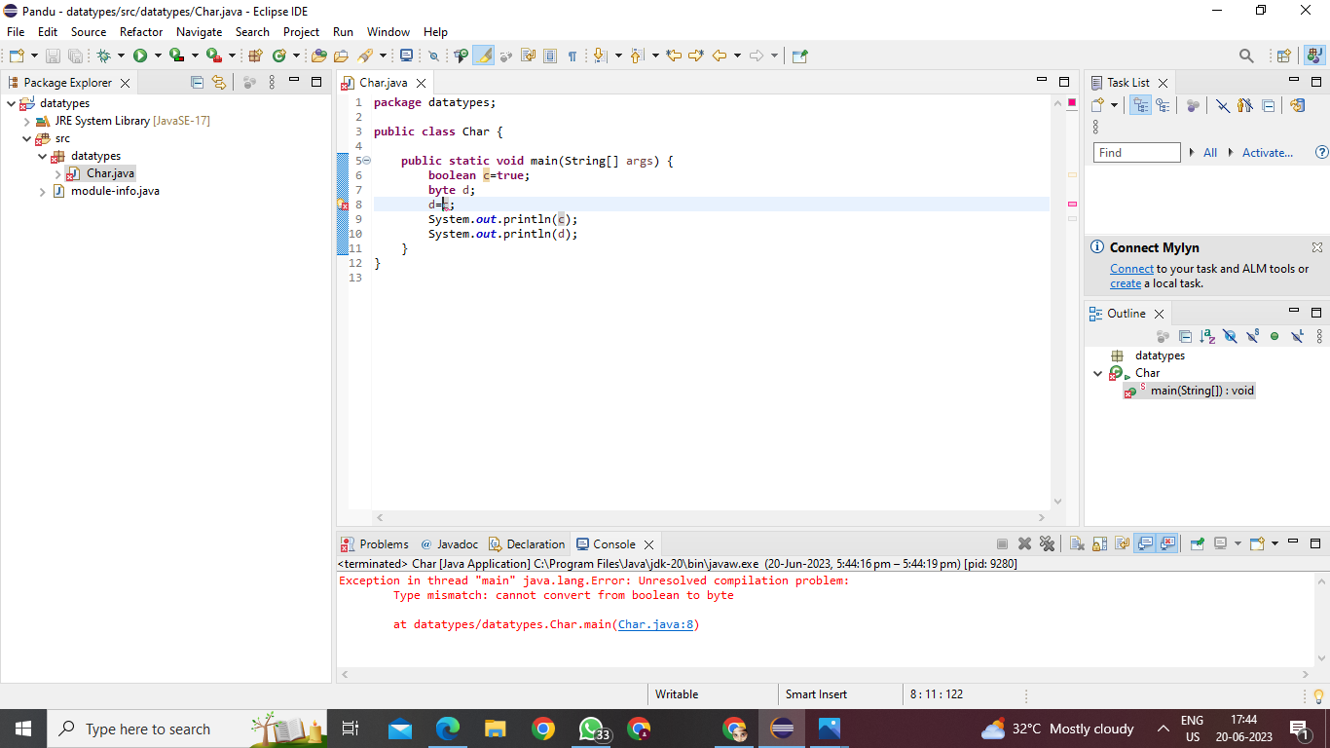

Not possible

3.boolean to short

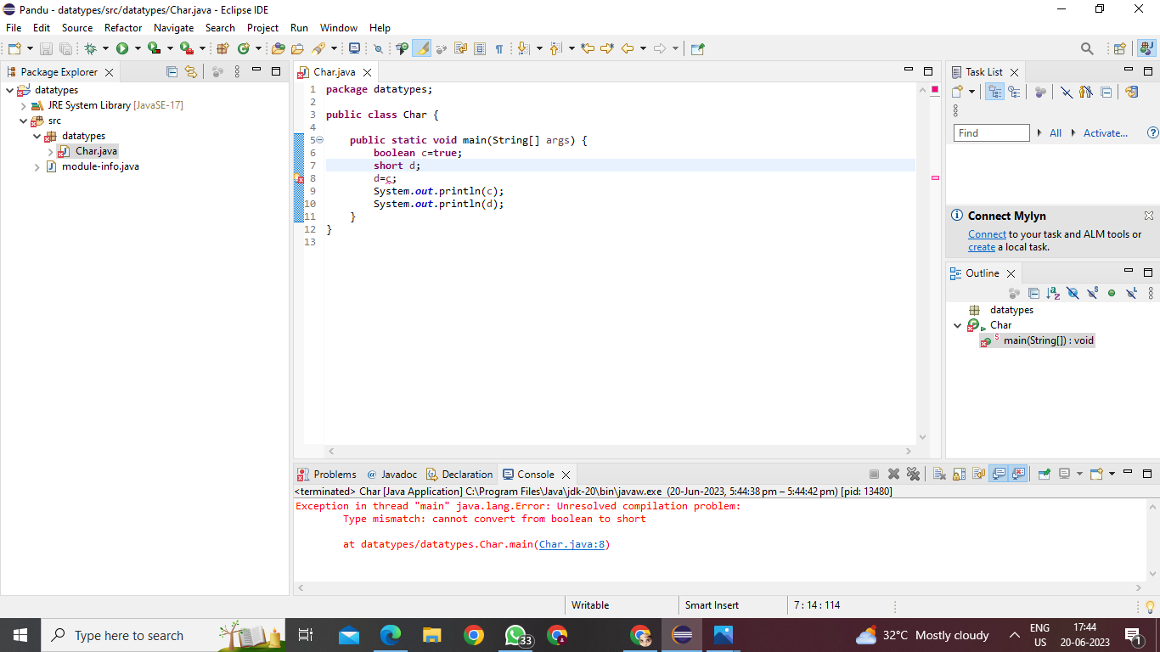

Not possible

4.boolean to int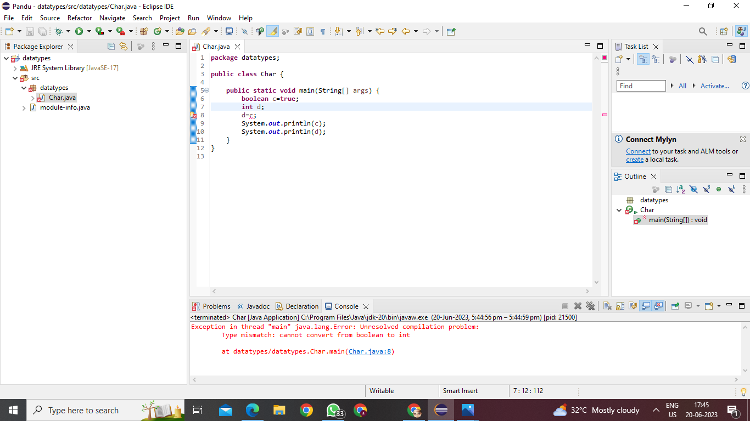

Not possible

5.boolean to long

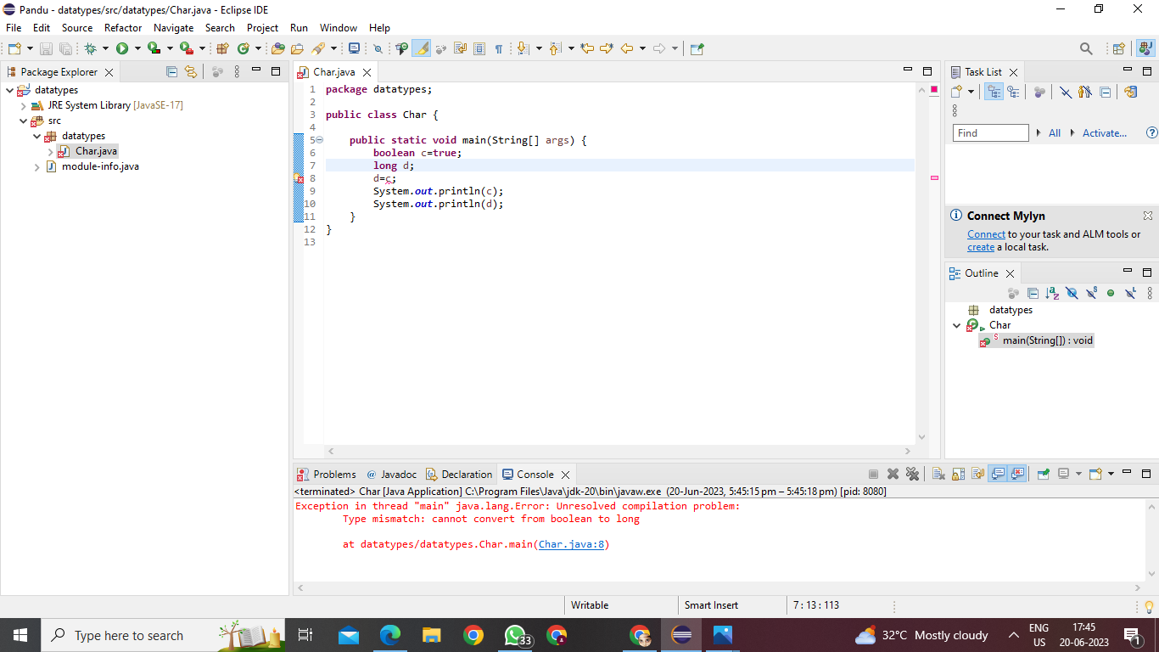

Not possible

6.boolean to float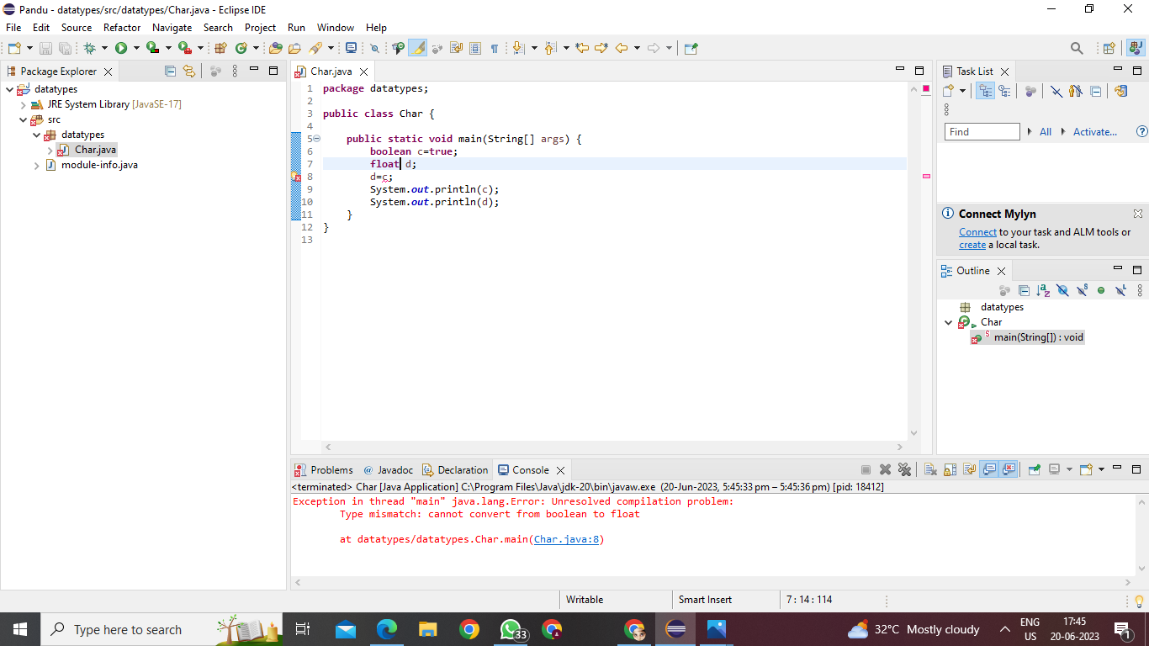

Not possible

7.boolean to double

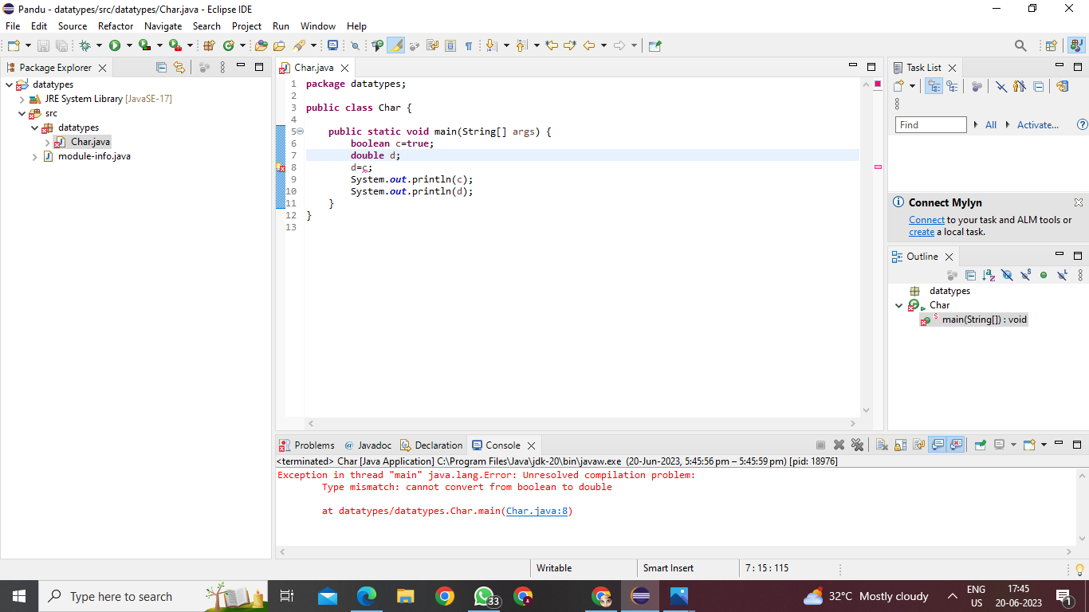

Not possible

8.boolean to boolean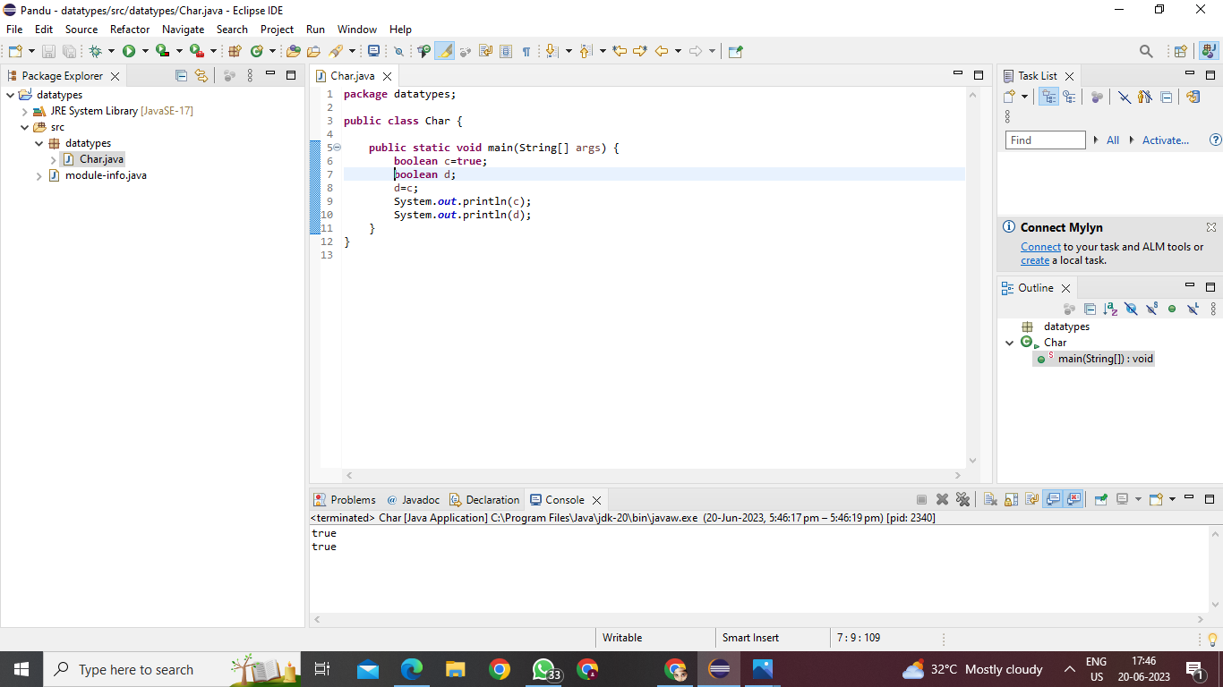

Casting not required

|  |  |  |  |  |  |  |  |  |
| --- | --- | --- | --- | --- | --- | --- | --- | --- |
|  | **CHAR** | **BYTE** | **SHORT** | **INT** | **LONG** | **FLOAT** | **DOUBLE** | **BOOLEAN** |
| **CHAR** | **CNR** | **EXPLICIT** | **IMPLICIT** | **IMPLICIT** | **IMPLICIT** | **CNR** | **IMPLICIT** | **CNR** |
| **BYTE** | **EXPLICIT** | **CNR** | **IMPLICIT** | **IMPLICIT** | **IMPLICIT** | **IMPLICIT** | **IMPLICIT** | **CNR** |
| **SHORT** | **EXPLICIT** | **EXPLICIT** | **CNR** | **IMPLICIT** | **IMPLICIT** | **IMPLICIT** | **IMPLICIT** | **CNR** |
| **INT** | **EXPLICIT** | **EXPLICIT** | **EXPLICIT** | **CNR** | **IMPLICIT** | **IMPLICIT** | **IMPLICIT** | **CNR** |
| **LONG** | **EXPLICIT** | **EXPLICIT** | **EXPLICIT** | **EXPLICIT** | **CNR** | **EXPLICIT** | **EXPLICIT** | **CNR** |
| **FLOAT** | **EXPLICIT** | **EXPLICIT** | **EXPLICIT** | **EXPLICIT** | **EXPLICIT** | **CNR** | **EXPLICIT** | **CNR** |
| **DOUBLE** | **EXPLICIT** | **EXPLICIT** | **EXPLICIT** | **EXPLICIT** | **EXPLICIT** | **EXPLICIT** | **CNR** | **CNR** |
| **BOOLEAN** | **CNR** | **CNR** | **CNR** | **CNR** | **CNR** | **CNR** | **CNR** | **CNR** |

